Registration and Abstract Submission FORM
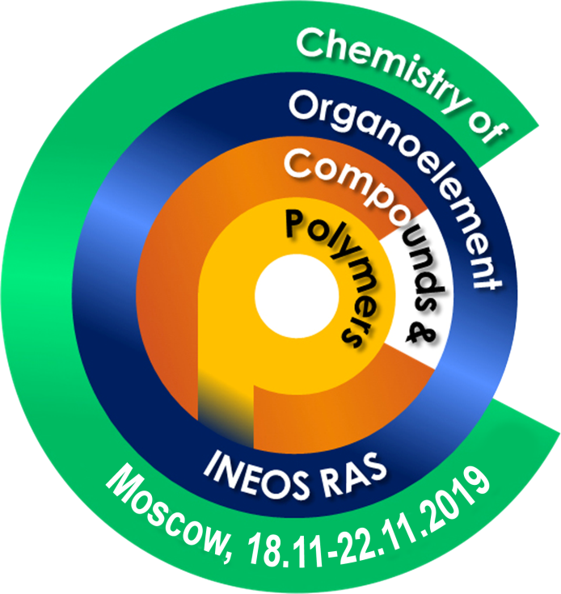

Please fill in the following form:

1. Valeriy Kuznetsov

2. Lomonosov Moscow State University

3. Russia/Moscow

4. valik-kuzia@mail.ru

5. +7(903)1954841

6. Poster

7. Polymers

ultrasonic synthesis of Water-soluble Polymer-metal(oxide) MAgnetic nanocomposite based on cross-linked calcium/sodium alginate and maghemite nanoparticles
Valeriy Kuznetsov^{a*}, Vasily Spiridonovª, Andrey Sybachinª, Mikhail Afanasovª, Lyudmila Makarova^{b}, Yulia Alyokhina^{b}, Eleonora Shtykova^{c}, Sergey Zezinª, Alexander Yaroslavovª
ªDepartment of Chemistry, Lomonosov Moscow State University, Russia, valik-kuzia@mail.ru
^{b}Department of Physics, Lomonosov Moscow State University, Russia
^{c}Shubnikov Institute of Crystallography, Federal Scientific Research Centre “Crystallography and Photonics,” Russian Academy of SciencesMoscowRussia

Synthesis of metal/organic materials containing magnetic nanoparticles is one of the actual tasks. Being combined with biological objects, magnetic nanoparticles can be used for such medical problems as controlled drug delivery, and magnetic-induced cancer therapy.^{1,2} Maghemite (γ-Fe₂O₃) represents an important class of magnetic transition metal oxide materials. To reduce the possible toxic effects of the magnetic phase, and to increase their physico-chemical stability, as well as create the possibility of immobilizing additional drugs, magnetic nanoparticles must be isolated. This problem can be solved by encapsulating the nanoparticles in some matrix materials.³
In this work, we used UltraSonication approach for the direct synthesis of hybrid non-toxic metal (oxide)−polymer magnetic nanocomposite. As a stabilizing matrix, a microgel based on Na-Alginate, preliminarily cross-linked by Ca²⁺ ions (Na/Ca-Alginate), was used. It was established that in the presence of the Na/Ca-Alginate microgel, maghemite nanoparticles stabilize into magnetically ordered structures which demonstrate the high magnetic properties. It was shown that the linear polysaccharide (Na-Alginate) cannot keep the nanoparticles from aggregation in the same conditions. The structural characterization of magnetic nanocomposite (Na/Ca-Alginate− Maghemite) were performed by X-ray diffraction (XRD) as well as Small Angle X-Rays Scattering (SAXS). Möessbauer spectroscopy was used too. The physicochemical properties of magnetic nanocomposite the were studied by techniques of Infrared spectroscopy (IR), Dynamic Light Scattering (DLS), laser microelectophoresis. The morphological analysis was performed by transmission electron microscopy (TEM). The magnetic behavior of organo-metal(oxide) magnetic nanocomposite (Na/Ca-Alginate−Maghemite) was studied by means of magnetization.
Acknowledgments
This work was supported by RFBR Project № 18-03-01024 А
References
1. Y. Huang, K. Mao, Materials Science and Engineering: C, 2017, 70(1), 763.
2. M. Häring, J. Schiller, Gels, 2015, 1(2),135.
3. M. Arruebo, W. Ho, Chem. Mater, 2008, 20(2), 486.

