Ultrafast estimation of radionuclides and heavy metal influence on halophilic bacteria inhabiting the polluted ecosystems

Anastasia Alexandrovskaya^{a,b}, Nadezhda Legkodimova^{b}, Konstantin German^{b,c*} Alexey Safonov^{c}, Tatiana Khijniak^{d}, Aleksandr Kopytin^{e}, Valeria Lyong^{c}, Pavel Melnikovª,

Nikolay Zaytsevª

ª Moscow Technological University, RF

^{b} Medical University Reaviz – Moscow branch, Russian Federation

^{c} A.N.Frumkin Institute of Physical Chemistry and Electrochemistry RAS, RF

^{d} Federal Research Centre Fundamental of Biotechnology RAS, RF

^{e} Institute of General and Inorganic Chemistry RAS, RF
* Corresponding author: guerman_k@mail.ru.

Pollution of the surface and underground water with radionuclides and heavy metals can lead to toxic intakes whilst water consumption results in human body intoxication through GIT (digestive tract). Usually, methods of maximum permissible concentration (MPC, for non-radioactive substances) and intervention limits (for radioactive) being used for a substance toxicity evaluation. These norms are developed in relation to a human being, and do not allow revealing toxic effect of any pollutant for specific microorganisms or for an ecosystem in general. Halophylic (chloride and fluoride) environments are possible to be formed for the radioactive wastes from some enrichment or spent fuel reprocessing (pyrhochemical) technologies.

Elaboration of the method for fast estimation of toxic influence of metals in the conditions of immediate and chronic experiments on cells of a prokaryotic organism of halophilic bacteria Halomonas mono sp. living in the polluted ecosystems was the general research objective of this work.

The objects of this research were the bacterial community of microorganisms some species of extremophilic bacteria inhabiting the polluted ecosystems. For an evaluation of toxic effect in acute and chronic experiments in work, a number of methods were used: bioelectrochemical (biosensor), colorimetric and potentiometric. Of high application interest are the methods based on dissolved oxygen on-line control. They provide rapid information on the living activity of the microorganisms under study. Several analyzers could be applied. The first is the oxygen analyzer model "Expert-001MTX" (based on the modified Clarke electrode) (Fig.1). The second possible is the oxygen analyzer designed recently with the stable optical oxygen sensing material based on perfluorinated polymer and fluorinated platinum(II) and palladium(II) porphyrins that have been described in [1].
As a result of an evaluation of toxic effect of metals in an ionic form in an acute experiment in aerobic conditions it was established that among the metals tested here the most toxic for prokaryotic cells are cesium cations and uranyl-ions.

Monitoring of chronic aerobic experiment has shown that the greatest toxicity was caused by uranium and technetium. Monitoring of chronic anaerobic experiment has shown that copper did not have toxic effect in the given small concentration, on the contrary, had the stimulating effect on the cell nitrate consumption because is the active site of some enzymes.

This work was supported by RFBR grant № 15-05-08919

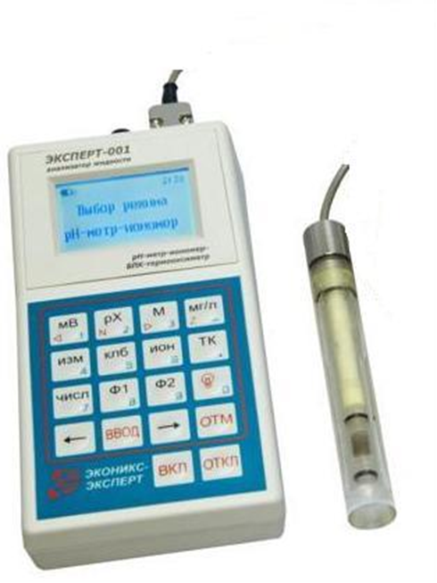
Fig.1. Oxygen analyzer model "Expert-001MTX", ECONIX, RF (based on the modified Clarke YSI electrode). | Fig.2. Metals toxic effects on  bacterial cells of Halomonas mono sp.

1. New biosensor method was elaborated and used for determining the toxicity of metals to bioreceptors of prokaryotic cells under the conditions of an acute experiment. An approach is developed to evaluate toxic indexes based on the results of the minimal effects of the toxicant LD_{min}.
2. The results of chronic experiments in aerobic conditions on the basis of Ldmin indicate the following row of metal toxicity toward the Halomonas mono sp.: Tc > V > U > La.

[1] N. K. Zaitsev, P. V. Melnikov, V. A. Alferov, A. V. Kopytin, K. E. German. Procedia Engineering. 168, 309 (2016 ).

