Surface-enhanced Raman spectroscopy of semiconducting monolayers
D. R. Maslennikov*¹, V.V. Bruevich¹, A.A Mannanov¹, E. V. Feldman¹, E.V. Agina²,
O.V. Borshchev², S.A. Ponomarenko², D.Yu. Paraschuk¹
¹Department of Physics and International Laser Center, Lomonosov Moscow State University
²Institute of Synthetic Polymeric Materials RAS
*dr.maslennikov@physics.msu.ru
Organic semiconducting monolayers have high potential for ultrathin electronics^{[1]}. The best monolayer electronic devices are based on crystalline monolayers. However, the local monolayer order has practically not been studied. To probe the monolayer domain structure with the spatial resolution less than 1 um, Raman spectroscopy can serve as a useful tool.
In this work, we report Raman study of semiconducting monolayers D2-Und-4T-Hex and O(Si-Und-PTTP-TMS)₂ (Fig 1. a, b) prepared by Langmuir technique. As the monolayers give a very weak Raman signal, to amplify it, we apply surface-enhanced Raman spectroscopy (SERS). To maximize the SERS signal-to-noise ratio(s/n), a Si substrate with gradual varying gold thickness (10–70nm) was prepared and then a monolayer film was deposited. The dependence of SERS s/n on the gold thickness shows the maximum at 20 nm. (Fig 1, c) We succeeded in obtaining Raman map for D2-Und-4T-Hex (Fig 1. d, e) and O(Si-Und-PTTP-TMS)₂. Using optical and atomic force microscopies, we found that D2-Und-4T-Hex films have a domain structure, where O(Si-Und-PTTP-TMS)₂ films do not. We discuss how the Raman maps are associated with structural features of the monolayers.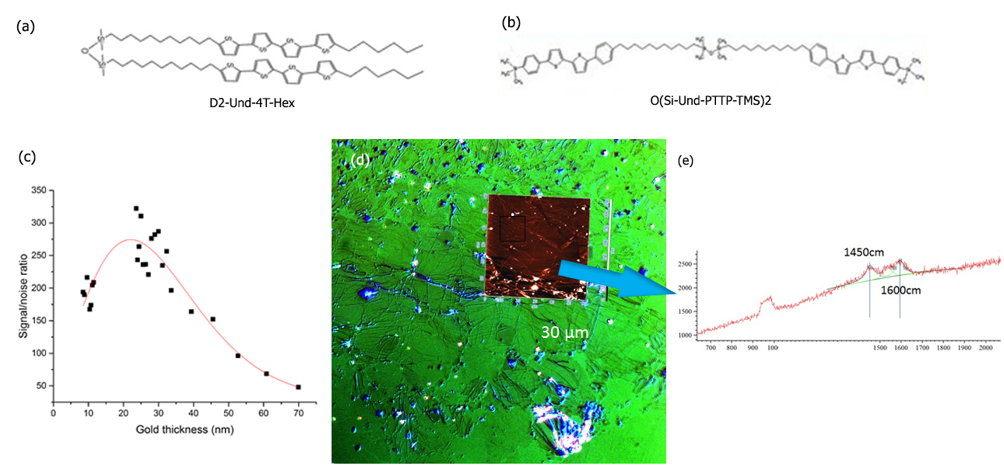

Fig.1. Chemical formula of (a) D2-Und-4T-Hex and (b) O(Si-Und-PTTP-TMS)₂ . (c) SERS signal-to-noise for O(Si-Und-PTTP-TMS)₂ monolayer. (d) Microscope image of the monolayer (C-DIC) and (e) Raman map from the selected area of D2-Und-4T-Hex. Red laser (633nm) with a power of 20mW was used for Raman excitation. Langmuir–Blodgett films were prepared using toluene solution with the concentration of substance of 0.33 g/l.
¹Smits, E. C. P. et al. Bottom-up organic integrated circuits. Nature 455, 956-959 (2008).

