УДК 553.065.1

**EXPERIMENTAL MODELLING OF ALKALINE METASOMATISM UNDER PRESSURE GRADIENT CONDITIONS AT 750оС.**

**Khodorevskaya L.I.**

D.S. Korzhinskii Institute of Experimental Mineralogy RAS, Chernogolovka Moscow district. (khodorevskaya@mail.ru). Tel.: +79166512553.

**ЭКСПЕРИМЕНТАЛЬНОЕ МОДЕЛИРОВАНИЕ ЩЕЛОЧНОГО МЕТАСОМАТОЗА В УСЛОВИЯХ ГРАДИЕНТА ДАВЛЕНИЯ ПРИ 750оС.**

**Ходоревская Л.И.**

Институт экспериментальной минералогии имени академика Д.С.Коржинского РАН, Черноголовка Московской обл. (khodorevskaya@mail.ru). Тел.: +79166512553.

**Abstract.** Compositions and specifity of formation of metasomatic minerals at conditions of Si, Ca and Mg transportation by alkaline solutions were studied. Gradients of temperature and pressure were created in an ampulla at external T=750 oC and P=500 MPa. At these conditions and presence of fluid H2O-Na2CO3 (XNa2CO3 = 0.07), diopside was dissolute, solutes were  transtported to and precipitated on amphibolite. This resulted in formation of alkaline asociations of Na-Ca amphibole, similar to cataphorite, aegirine, aegirine-augite, nepheline on the amphibolite surface. It was shown previously, the aegirine and nepheline are not formed at less content  of the salt in the fluid (XNa2CO3 = 0.035). Accordingly, appearance of the aegirine and nepheline evidents increasing of fluid alkalinity, in particular, increasing XNa2CO3 to values exceeding 0.05.

***Keywords****: aegirine; aegirine-augite; amphibole; katophorite; nepheline;* *alkaline metasomatism; fluid.*

**Аннотация.** Изучены составы и особенности формирования метасоматических минералов в условиях транспорта Si, Ca и Mg щелочными растворами. При задаваемых внешних параметрах 750оС, 500 МПа в ампуле создавались условия градиента Т и Р. При этих условиях и в присутствии флюида H2O-Na2CO3 (XNa2CO3 = 0,07) диопсид растворялся, растворенные вещества транспортировались и осаждались на амфиболите. Это привело к образованию ассоциаций Na-Ca амфибола, сходного с катафоритом, эгирина, эгирин-авгита и нефелина на поверхности амфиболита. Ранее было показано, что эгирин и нефелин не образуются при меньшем содержании соли во флюидах (XNa2CO3 = 0.035). Таким образом, появление в метасоматической зональности эгирина отражает возрастание щелочности флюида, вплоть до значений XNa2CO3 ≥ 0.05.

**Ключевые слова:** *эгирин; эгирин-авгит; амфибол; катафорит; нефелин; щелочной метасоматизм; флюид.*

A great variety of alkaline metasomatic rocks from phenites associated with plutonic alkaline complexes and carbonatites to low-temperature alkaline rocks is largely dependent on the presence of fluids filtering along circulation zones. Therefore, fluid phase composition is studied to assess conditions for the fluid mobilization and transport of large-ion lithophile (LILE), high-charge (HFSE) and rare-earth (REE) elements characteristic of alkaline rocks.

The genesis of alkaline metasomatic rocks is largely dependent on Na regime. Na activity in alkaline fluids is essential as it is responsible for the evolution of alkaline metasomatic rocks such as albite, aegirine, as well as Ca-Na and Na- amphiboles. These minerals are important indicators of carbonatites; metasomatic rocks themselves occasionally host rare-metal (Nb, Zr, REE) mineralization (Savelyeva et al. 2017; Korchak, 2008; Melgarejo et al.*,* 2012; Chakhmouradian et al.,2015 et al.).

The experimental study of phase relations indicate the leading role of the ligands F-, Cl-, PO43- and SO42- in fluids upon the transfer of HFSE and REE during contact metasomatism (Arzamastsev et al., 2011;). Furthermore, sodium carbonate fluids play an important role in alkaline metasomatism (Kushev, 1972; Savelyeva et al., 2018; et al.).

The results of the modeling of the transfer of petrogenic components by the fluid Na2CO3-H2O (XNa2CO3=0.035) at preset external parameters (T=750оС, P=500 MPa) under P-T gradient conditions created inside an ampoule were reported in (Khodorevskaya, 2019). Diopside was used as the source of transferred Si, Ca and Mg in the experiments. During the experiments diopside was partly dissolved under gradient conditions. Some of dissolved substances remained in solution, while others precipitated on the substrate as an amphibole rim. Newly-formed amphibole was Mg-cataphorite (Mg-*Ktp)* with an iron content (*f*) of 0.27-0.05.

However, alkaline pyroxenes, which were not obtained in the experiments, commonly occur together with sodium-calcium and sodium amphiboles in natural alkaline metasomatic rocks. This seems to be due to low salt (Na2CO3) concentration in the fluid. Therefore, this project is a continuation of studies conducted under gradient conditions at 750оС and at higher salt concentrations in the fluids (XNa2CO3=0.07).

After the experiments, newly-formed minerals, occurring as a continuous or discontinuous rim, were revealed in some portions of the margin of fluid-facing *Grt*-amphibolite (Fig. 1). The rim varied in thickness from 0 to over 500 µm. The newly-formed minerals in the rim are shown in more detail in Fig. 2.

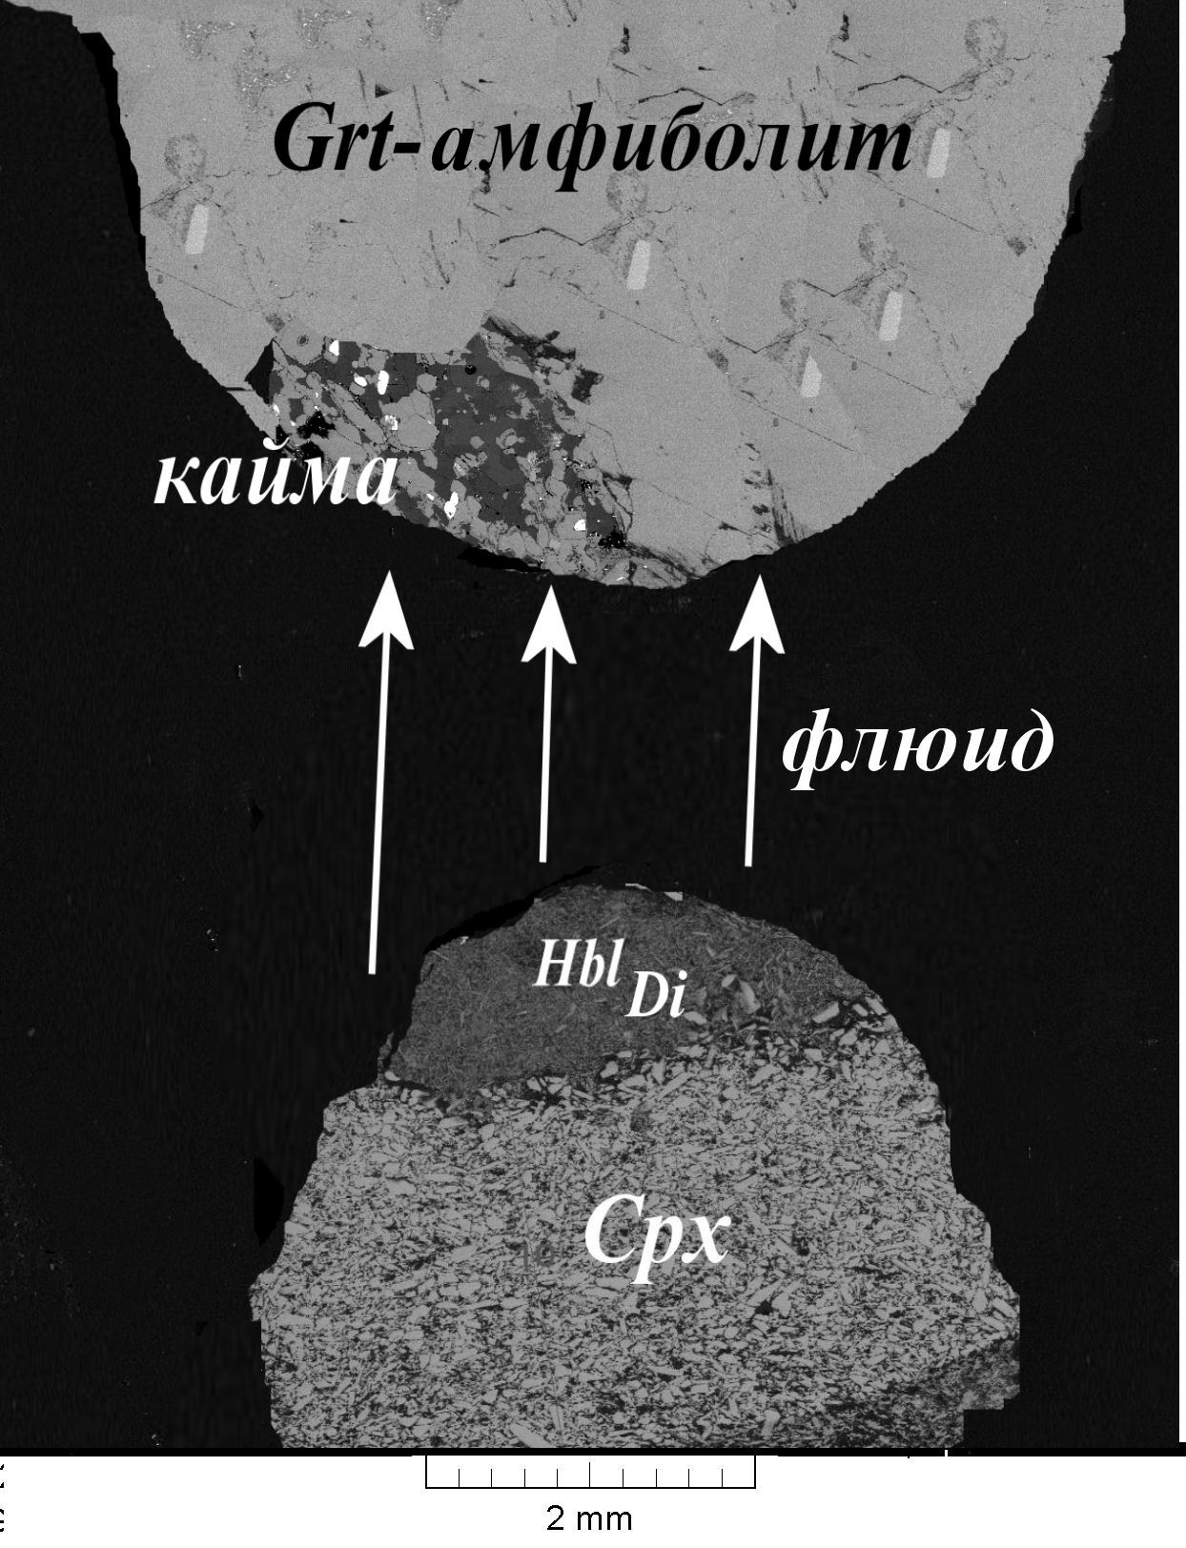 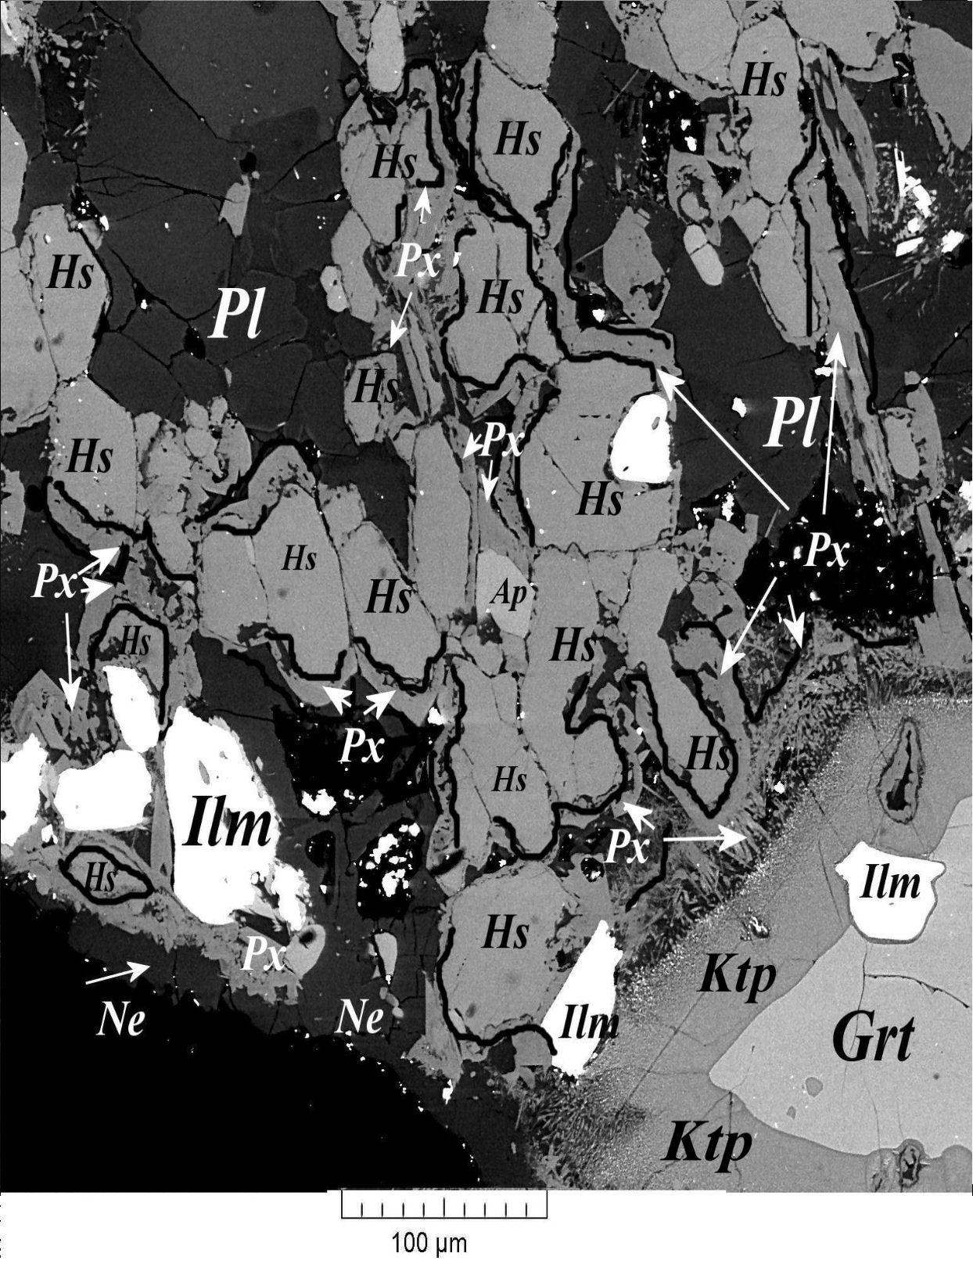

**Fig. 1.** The scheme of the experiment. The arrows indicate the direction of fluid transfer from diopside to *Grt*-amphibolite.

**Fig. 2.** Newly-formed mineral rim. The black line indicates narrow aegirine-augite rims along amphibole margins.

The fluid-facing margin of amphibolite (Fig. 2) has a discontinuous nepheline rim with an excess of SiO2 up to 0.22 ф.ед. and FeO impurity of up to 0.05 ф.ед. Plagioclase, similar in composition, occurs both in the middle of the sample and at the contact with the fluid (*An20*). Obviously, felsic plagioclase from amphibolite remains stable in the contact zone.

The amphiboles that make up *Grt* amphibolite occurred as hastingsite (*Hs*) с *f* = 0.55. *Hs* persisted in the fluid contact zone after the experiments (Fig. 2); iron concentration increased to *f* = 0.62 from the centre to grain margins.

Narrow, 10 µm thick, well-defined newly-formed pyroxene rims (in Fig. 2, *Px* rims are indicated by a black line) formed along the *Hs* margins. The clinopyroxene is consistent in composition with aegirine and aegirine-augite (Fig. 3). The mineral is rich in FeO (≈ 22-25 mas.%) and TiO2 (a few per cent). The iron content of the mineral *f =* 0.70-0.80.

The composition of partly preserved garnet is enriched in almandine from the centre to grain margins, varying from *Grs13Alm68Prp9Sps7*  to *Grs12Alm75Prp8Sps7*.

A ≈ 50 µm wide rim was formed along the garnet margins. Recalculation of the chemical composition of this mineral for the formula of amphibole is consistent with the values (Na0.6-0.9K0.1Ca0.05)(Mg2.4-2.6Fe0.2Ti0.1Al0.2)(Si2.8Al1.2O10) (OH)2. The mineral is the closest in composition and cation ratio to sodium-calcium amphiboles - cataphorites (*Ktp*, Figs. 2 and 4). However, the mineral contains more Na than the cataphorites. Too high Na concentrations in this mineral could be due to the excess of fluid relative to the sample and high Na concentrations in the fluid. Na seems to be adsorbed as part of film solutions on the mineral surface.

(AlVI+Ca) – (Si+Na+K) ratios in the amphiboles, obtained at both XNa2CO3=0.035 and XNa2CO3=0.07 in the fluid, are similar (Fig. 4). However, the newly-formed amphiboles, obtained in more salty fluids, are much richer in iron (*f* = 0.80).

Cpx.tif рис4.TIF

**Fig. 4.** Compositional characteristics of *Hbl* produced in the experiments: 1-2 – respectively experiments with XNa2CO3=0.035 и XNa2CO3=0.07 in fluid; 3-XNaCl=0-0.45 (Khodorevskaya, Aranovich, 2016; 4 – data (Savelyeva et al., 2017; 5 - end members of *Hbl* according to (Leake et al., 1997).

**Fig. 3.** The compositions of pyroxenes formed in the experiments

Triangles in Fig. 4 show amphibole compositions formed at varying NaCl concentrations in the fluid (Khodorevskaya & Aranovich, 2016). One can see that it is the increasing alkalinity of the fluid that is responsible for variations in amphibole composition. Near-neutral solutions are responsible for the presence of edenites and pargasite-hastingsites. As the alkaline content of the solutions increases (XNa2CO3≈ 0.03-0.1), cataphorites are formed. Riebeckites and arfvedsonites seem to form at higher alkalinity.

Thus, the experiments show that minerals, characteristic of alkaline metasomatic rocks, are formed if Na2CO3 is present as part of the fluid phase. Na-Ca amphibole – cataphorite with *f* = 0.05-27 is formed at relatively low salt concentrations (XNa2CO3 = 0,035). As fluid salinity increases (XNa2CO3 = 0.07), aegirine, aegirine-augite and nepheline are formed together with cataphorite. Newly-formed aegirine and cataphorite contain practically identical high iron concentrations (*f* = 0.80).

The above experimental studies, as well as the data reported in (Khodorevskaya, 2019), indicate that the removal of elements, dependent on the composition of the fluid phase, including its anion constituent, takes place when T-P parameters display a gradient. The largely aqueous fluid, as well as low chloride (H+, Na+, K+) concentrations contribute to the removal of Ca, Fe and Mg from host rocks. As NaCl concentration in the fluid rises (XNACl ≈ 0.1), из вмещающих пород выносятся Fe and Mg are removed from the host rocks, while Ca behaves like an inert constituent. Largely aqueous fluids with small amounts of salt added are responsible for the formation of basificates in granitization processes. High iron concentrations in dark-coloured minerals and the abundance of magnetite and hematite in the basificates are observed, because more iron and less Ca and Mg are removed from host rocks. The presence of carbonate ions in the solutions results in the removal of SiO2 and CaO (Khodorevskaya, 2019) and lesser Fe from the rocks and inert Mg. Thus, the presence of carbonatites with no visible relation to alkaline-basic magmatite series could be due to the presence of sodium carbonate fluids responsible for the removal of Ca from host rocks and its redeposition into carbonates.

*This study was carried out under government-financed project AAAA-А18-118020590148-3 for the Korzhinskii Institute of Experimental Mineralogy, Russian Academy of Sciences, in 2019–2020*

References

Арзамасцев А. А., Арзамасцева Л. В., Зарайский Г.П. Контактовое взаимодействие агпаитовых магм с гнейсами фундамента: на примере Хибинского и Ловозерского массивов // Петрология. — 2011. № 2. — С. 115–139.

Корчак Ю.А. Минералогия пород ловозерской свиты и продуктов их контактово-метасоматического преобразования в щелочных массивах: Автореф. дис. канд. геол.-мин.наук. — Санкт Петербург, 2008. — 18 с.

Савельева В. Б., Базарова Е. П., Шарыгин В. В., Карманов Н. С., Канакин С. В. Метасоматиты Онгуренского карбонатитового комплекса (Западное Прибайкалье): геохимия и состав акцессорных минералов // Геология рудных месторождений. — 2017. № 4. — С. 319–346.

Кушев В.Г. Щелочные метасоматиты докембрия. — Ленинград, 1972. —190 с

Ходоревская Л.И. Экспериментальное изучение взаимодействия диопсида с флюидом H2O-Na2CO3 в условиях градиента давления при 750оС // Труды Всероссийского ежегодного семинара по экспериментальной минералогии, петрологии и геохимии (ВЕСЭМПГ-2019). — Москва, 2019а. — С. 122-125.

Ходоревская Л.И. Гранитизация и высокотемпературный метасоматоз в породах основного состава: сопоставление экспериментальных и природных данных // Петрология. — 2019б. № 5. — С. 557-576.

Chakhmouradian A.R., Reguir E.P., Kressal R.D. et al. Carbonatite-hosted niobium deposit at Aley, northern British Columbia (Canada): mineralogy, geochemistry and petrogenesis // Ore. Geol. Rev. — 2015. V. 64. — P. 642–666.

Leake B.E., Woolley A.R., Birch W.D. et al. Nomenclature of amphiboles. Report of the Subcommittee on Amphiboles of the International Mineralogical Association Commission on New Minerals and Mineral Names // Eur. J. Mineral. —

1997. V. 9. — P. 623–651.

Melgarejo J.C., Costanzo A., Bambi A.C.J.M. et al. Subsolidus processes as a key factor on the distribution of Nb species in plutonic carbonatites: The Tchivira case, Angola // Lithos. — 2012. V. 152. P. — 187–201.