Acoustic properties of Gavruni vowels
Prof. VB Ivanov (IAAS, Moscow State University, iranorus@mail.ru), Dr. LR Dodykhudoeva (IL, Russian Academy of Sciences, leiladod@yahoo.com)
The native language of Zoroastrians in Iran is called Gavruni, Gavri or Dari by the speakers themselves. It has 2 main branches: Yazdi (of those who live in the city of Yazd and its environment) and Kermani (of those who live in Kerman, see Figure 1, slide 2). The latter has nearly disappeared, because the number of speakers is somewhat near 100 and only women continue to speak that language in families. The number of Yazdi speakers is approximately 5000 thousands according to the estimate of a mobed with whom we spoke this year. The distribution of Gavruni is shown in 2 ellipses on slide 3.

Figure 1. Main branches of Gavruni (slide 2)
From the point of view vowels we can divide the Yazdi branch into 2 vernaculars (subbranches): Xorramšāhi and Mahallei. The latter seems to be more spread over this region. The difference can be clearly heard even in name of their language: Xorramšāhi people pronounce it like [gāvruni] with velarized [g], while Mahallei people pronounce it [gavruni] with palatalized [g] (like in Persian word گز [gaz] ell, tamarisk). Our paper mostly deals with Mahallei pronunciation.
Previous descriptions of Gavruni vocalic system were made by K. Mazdapur (1995) and F. Firuzbaxš (1996) (slide 4). They do not differ very much and were made by their own perception (see Figure 2, slide 5). Both have a problem: vowel [â] is out of place. We discussed it with the author of this system K. Mazdapur and she herself pronounces it like closed long [ō] very close to [u], but insists that it is some kind of long [ā]. I promised her to represent her opinion but still we designate it as long [ō]. Beside that there is one more rather rare short vowel [ə] – schwa – that can occur in an unstressed position only and that was not plotted on the articular plane by previous authors.
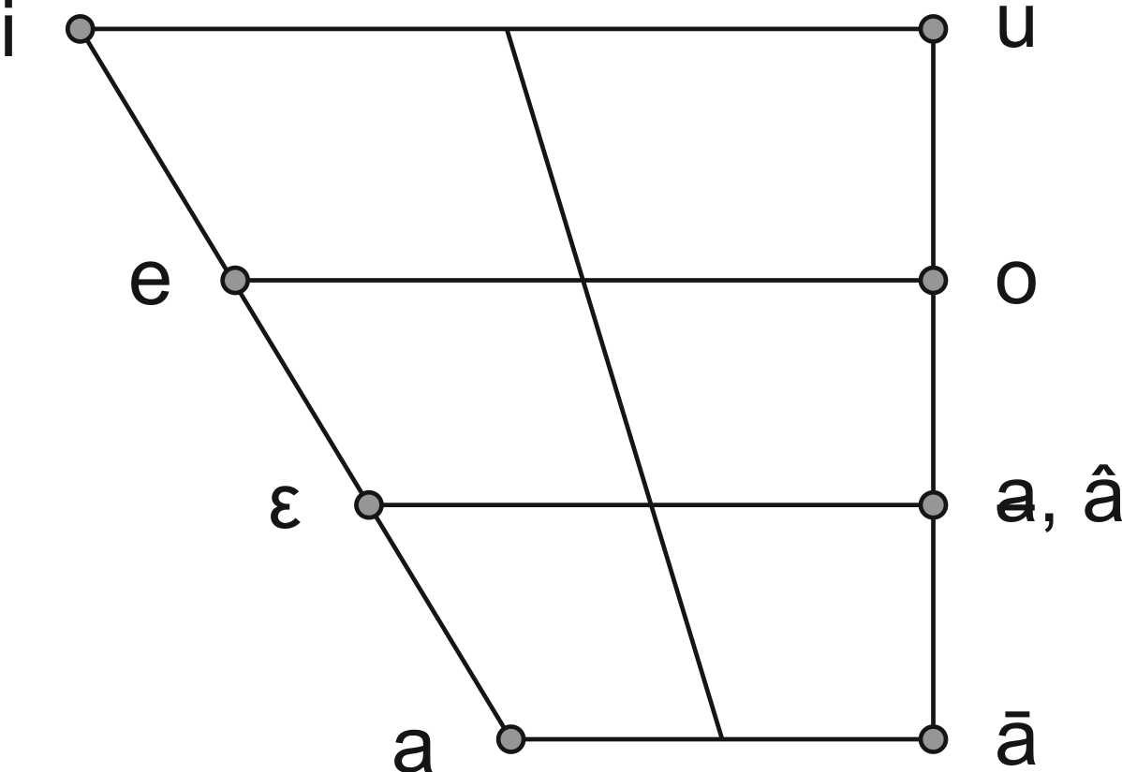
Figure 2. Previous auditory vowels systems (slide 5)
We corrected that system (still auditory without any instrumental analysis, see (Ivanov, 2005), (Иванов, и др., 2008), (Иванов, и др., 2007), (ایوانف, 1383 (2004) سال هفدهم), slide 6), putting [ō] and [ə] into their right positions (see Figure 3, slide 7). The phonological status of those vowels is different. [i], [u], [a], [o] are full phonemes. They can be found in any position (stressed or unstressed, in contact with any consonant).
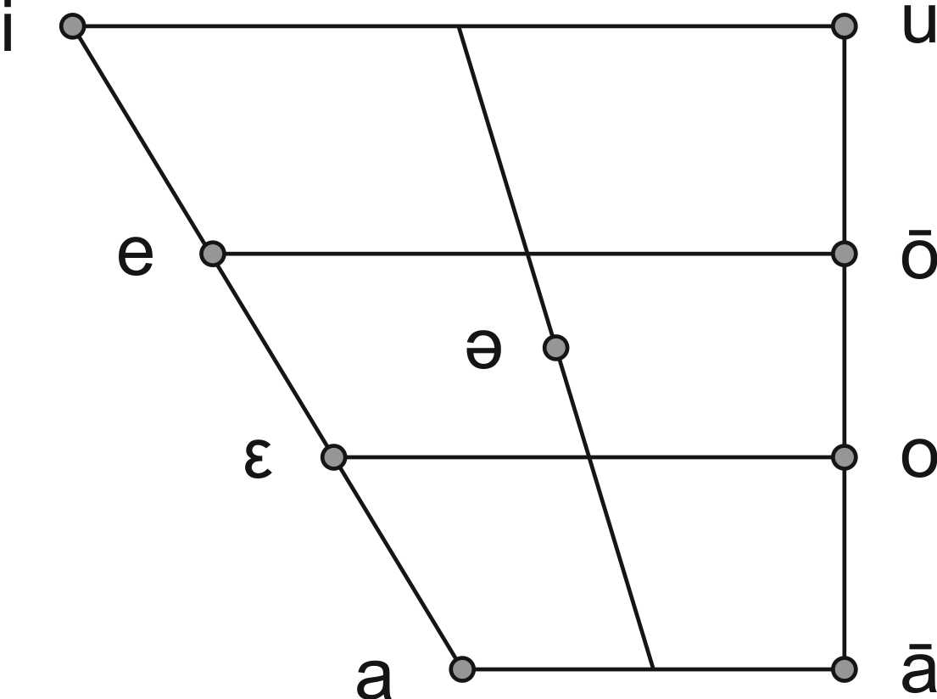
Figure 3. Corrected auditory vowels system (slide 7)
[e] turns into [ε] in contact with sonorous consonants like [r], [n], [m]: pεnj five, qɛrmez red etc.
[ə] – schwa – (in some cases prothetic) can be found in pretonic open syllables. It corresponds to Persian short vowels [a, e, o] in the same position: bǝnavše violet, nǝvad 90, šǝmōri number etc. Vowel [ᵻ] occurred in the speech of one of our male informants as a combination of [e] and [y]: šəmōrᵻy number (gav.) ← šomāre-ye number (per.).
In Mahallei [ā] can be found in Persian loan words: kǝlā hat, šāyad may be. In Xorramšāhi in many words it is pronounced instead of [ā].
Table 1. Mean length of vowels (slide 9)
Vowel | Mean length in msec | Vowel | Mean length in msec
õ | 281 | i | 173
ō | 214 | u | 167
ε | 207 | e | 146
ā | 196 | o | 132
a | 193 | ǝ | 56
In fluent speech some sequences of vowel + consonant in most frequent words combine into one vowel that bears both characteristics of vowel and consonant: enclitic -on is turns into nasal [õ]. Verbal ending -εn (3rd person, plural) turns into nasal [ɛ͂]: vezɛn they run → vezɛ͂. Sequence -un- gives us nasal -ũ-: punzdā 15 → pũzdā. Thus phonetically 3 more nasal vowels [õ, ɛ͂, ũ] occur in Gavruni that cannot be considered to be phonemes.
Gavruni’s [ō] historically speaking is a derivative from Protoiranian [ā]: ōbi blue (gav.) ← ābi blue (per.). Long vowels, especially [ō] in full style of pronunciation demonstrate diphtongoidness. Usually their beginning is an open syllable then they tend to be closer: tōj-on crown is → tōwj-on. Thus another diphtongoidal element in the vocalic system can be found – non-syllabic [u̯].

Figure 4. Mean length of female vowels in msec (slide 10)
We recorded speech of 7 native speakers of Mahallei vernacular (4 men and 3 women; some of them this year). We took for instrumental analysis 251 samples of their speech. Among them there are the following examples (stress is shown in bold letters):
čōrda fourteen; dotog girl; gavrun Zoroastrian; ketōb book; navrus scissors; ōbi blue; parvōs fly; pran-i shirt; šɛmdun candlestick; sou̯r-on red is; voftuva ewer; xina reeds; zard-õn yellow is; dōrεn they have (slide 8).
Table 2. Formant structure of female vowels (slide 11)
Vowels | F₁ | F₂ | F₃ | Vowels | F₁ | F₂ | F₃
i | 324 | 2766 | 3441 | ā | 636 | 1198 | 2947
e | 489 | 2425 | 3131 | o | 402 | 1056 | 2968
ε | 515 | 2143 | 2991 | õ | 310 | 1026 | 2185
ǝ | 513 | 1851 | 2973 | ō | 441 | 975 | 2933
a | 776 | 1594 | 2597 | u | 327 | 893 | 2685
Mean length of vowels measured in those samples are shown in Table 1 (slide 9). Corresponding histogram is shown on Figure 4 (slide 10). The vowels are sorted according to their length.
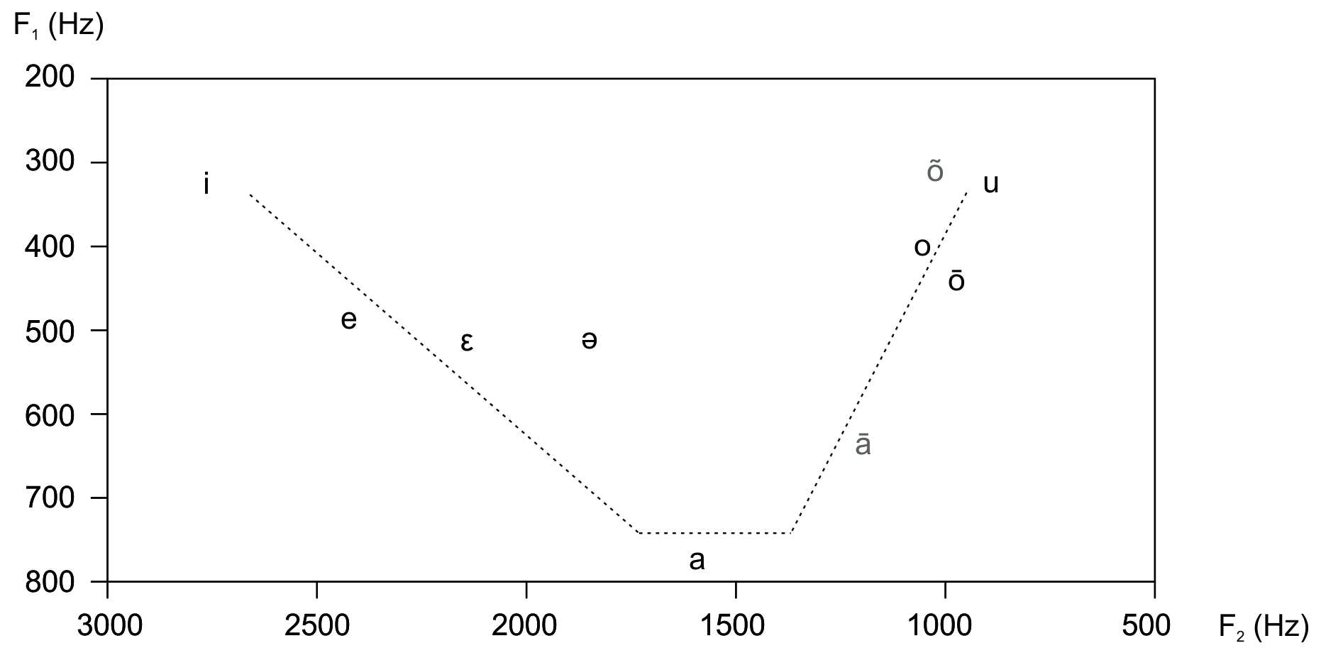
Figure 5. Female vowels in 2-dimensional acoustical space (slide 13)
The longest one is [õ] (281 msec). It is quite natural, because it combines 2 phonemes [o] and [n]. The next one is [ō] (214 msec), because both [o]s are very close in articulation and in order to be distinguished in speech they must be opposed in length. Thus the reason for its considerable length lies in phonology.
Open [ε] opposes closed [e] for the same reason. Besides that usually open vowels are more energetic i.e. they have more intensity and duration. Then we see a set of open vowels [ā, a]. Those vowels contrast in their formant structures (much more than o-like and e-like vowels as it will be shown later), so they do not need to have much difference in length. Besides that [ā] belongs to another language – Persian (at least in Mahallei) – so it is to some extent out of the system. [i] and [u] are long but closed vowels. The latter attribute shortens their duration. Thus, they find themselves in the middle of the histogram. We may come to the conclusion that openness is a more powerful factor than the phonological length. The shortest vowel is [ə]. Its length (56 msec) is less than the duration of many fricative consonants like [s], [š] etc.
Table 3. Mean formants of male vowels (slide 14)
Vowel | F₁ | F₂ | F₃ | Vowel | F₁ | F₂ | F₃
i | 294 | 2199 | 2747 | ā | 649 | 1266 | 2759
e | 403 | 1928 | 2487 | o | 427 | 1041 | 2668
ε | 522 | 1828 | 2630 | õ | 629 | 1077 | 2951
ᵻ | 356 | 1706 | 2187 | ō | 383 | 904 | 2694
ǝ | 422 | 1519 | 2524 | u | 299 | 966 | 2264
a | 661 | 1465 | 2492 | u̯ | 326 | 807 | 2618
In any language formant structures for male and female voices are different. The mean formant data for female vowels are shown in Table 2 (slide 11). 3 formants are plotted on an F-plane on slide 12. The points, corresponding to first 2 formants are shown on a 2-dimensional F₁/F₂-plane on Figure 5 (slide 13).
First of all we see that the acoustic space is very similar to our habitual schemes (see Figure 3, slide 7), but not the same. The closed back row vowels [o, õ, ō, u] are very close to each other. In order to maintain the intelligibility of the speech they have to differ in some other dimension/dimensions. That dimension is their length (see Figure 4, slide 10, discussed earlier).
`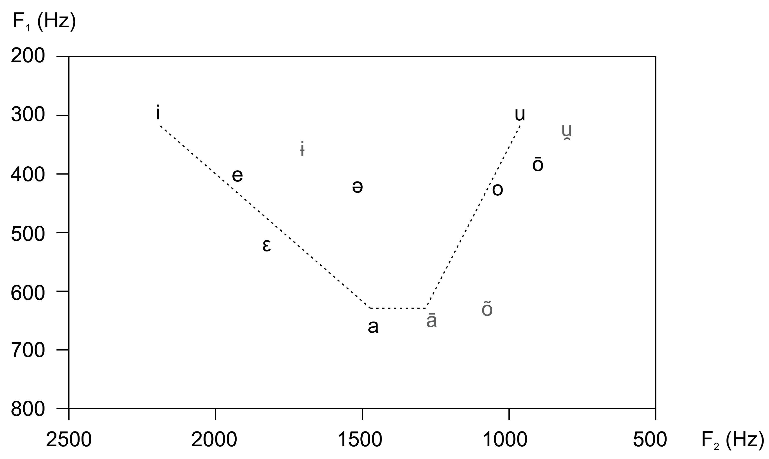
Figure 6. Male vowels on F1/F2-plane (slide 16)
It is clearly seen that long [ō] is much higher than Persian [ā], thus the experimental samples of female voices confirms our corrected system (see Figure 3, slide 7). E-like vowels in the front row are close to each other in the acoustic space, so they need additional contrast in length too. All of them have good offset to [i] and to [a] as well. Counter to Persian – Gavruni’s [a] tends to lie in the middle of the lower ascent. The reason for this is that long [ā] is out of the system and wouldn’t limit short [a] to lie in the front row region.
Table 4. t-test for equality of lengths of [ō] vs. [o] (slide 17)
 | Levene’s Test for Equality of Variances |  | t-test for Equality of Means
 | F | Significance | t | df | Significance (2-tailed) | Mean Difference | Std. Error Difference | 95% Confidence Interval of the Difference
 |  |  |  |  |  |  |  | Lower | Upper
Equal variances assumed | 1.895 | .175 | 4.566 | 49 | .000 | 81.36 | 17.82 | 45.55 | 117.18
Equal variances not assumed |  |  | 4.065 | 25.444 | .000 | 81.36 | 20.02 | 40.17 | 122.55
The articulatory apparatus of a woman is smaller in dimension, that’s why all the vowels are shifted up, especially in the 2nd formant (F₂). F₂ in female speech reaches 3000 Hz and F₁ goes as high as 750 Hz. Male vowels are shifted down (see Table 3, slide 14 and Figure 6, slide 16). Their F₂ wouldn’t exceed 2500 Hz and F₁ – 650 Hz. Some differences can be seen in relation to Figure 5 (slide 13).
Our considerations about the difference between vowels in length and in formants must be proved by statistical analysis. ANOVA was used to do that. The results of checking the length of [ō] vs. [o] in SPSS is shown in Table 4 (slide 17).
In the left part of it we see the results of Levene’s Test for Equality of Variances. As the Significance is only 0.175 (i.e. much higher than the critical level 0.05) equal variances are not assumed. In lower row we read that 2-tailed significance of opposition is 0.000. That means that the figure is less than 0.001 i.e. the contrast in length between [ō] and [o] is highly significant. The difference in msec according to 95% Confidence Interval of the Difference lies somewhere 40 and 122 msec.
The number of samples for each vocalic token can be seen on slide 18.
Table 5.Multivariate Test of Between-Vowel Effects
F₁ R Squared = 0.983; F₂ R Squared = 0.987 (Slide 20)
Source | Formants | Sum of Squares | Degrees of Freedom | Mean Square | F | Significance
Model | F₁ | 28612045 | 9 | 3179116 | 743.045 | .000
 | F₂ | 280976721 | 9 | 31219635 | 976.519 | .000
Vowels | F₁ | 28612045 | 9 | 3179116 | 743.045 | .000
 | F₂ | 280976721 | 9 | 31219635 | 976.519 | .000
Error | F₁ | 483470 | 113 | 4278
 | F₂ | 3612647 | 113 | 31970
Total | F₁ | 29095516 | 122
 | F₂ | 284589369 | 122
Statistics can help us to estimate the contrasts between vowels on F₁/F₂-plane i.e. the intelligibility of the Gavruni speech. You can see that the Significance of the contrasts in Gavruni vocalism is very high (0.000 in bold digits in the right column of Table 5, slide 20). Statistical parameter R Squared shows us the quality of model. The closer it is to 1, the better. Our figures for these parameters are very good in this respect: F₁ R Squared = 0.983; F₂ R Squared = 0.987. That means that almost all the data is explained by the model. The contrasts of the F₁/F₂-system is shown on (slide 21).
Two first formants – F₁ and F₂ – determine the position of the tongue in the mouth. If we want to judge on labialization of the vowels, you should take into consideration the third formant (F₃) as well. So instead of a plane you get a 3-dimensional figure – a F₁/F₂/F₃-cube, where the 3rd dimension determines labialization. The contrasts of the whole system is shown on Table 6 (slide 22).
Table 6. Vowels’ Contrast in F₁/F₂/F₃-cube (slide 22)
Vowels Deviation Contrast |  | Dependent Variable
 |  | F1 | F2 | F3
ā | Contrast Estimate | 210.050 | -107.070 | 175.140
 | Significance | .000 | .261 | .186
a | Contrast Estimate | 222.260 | 92.050 | -92.520
 | Significance | .000 | .011 | .063
e | Contrast Estimate | -36.050 | 554.290 | -97.380
 | Significance | .077 | .000 | .206
ǝ | Contrast Estimate | -17.120 | 145.590 | -59.850
 | Significance | .498 | .037 | .532
i | Contrast Estimate | -144.480 | 825.590 | 163.070
 | Significance | .000 | .000 | .007
ō | Contrast Estimate | -51.260 | -526.180 | 77.890
 | Significance | .006 | .000 | .259
o | Contrast Estimate | -11.520 | -332.790 | 84.190
 | Significance | .447 | .000 | .145
u | Contrast Estimate | -141.050 | -539.810 | -330.080
 | Significance | .000 | .000 | .000
ɛ | Contrast Estimate | 82.620 | 454.730 | 46.240
 | Significance | .001 | .000 | .605
Those vowels, which have bold zeros below F₁ and F₂, are fully decentralized like [i, u, ɛ, ō]. Others are in respect closer to the center of the cube: in the terms of row like [a, ā] or in the terms of ascent like [o, e]. The closest to the center of the cube is [ə].
You can see the formant tracks of a Gavruni phrase šəmōri yak number one on Figure 7 (slide 23, produced by Praat). There is clearly seen the diphtongoidness of relatively long vowels [ō, i, a]. There is no pause between the words.
You can see Avestan vowels on Figure 8 (slide 24). Long vowels in Avestan have no phonologic significance and do not distinguish words. There are quantitative variants of short vowels that are articulatory the same. They are drawled for the convenience of singing priests. As I was told in Mumbai, the priests drawl the vowels as long as they must have time to take some object from one place and to put it another place. If we extrapolate the nowadays Gavruni pronunciation to the beginning of the Sassanid’s era and combine it with Middle Persian vowel system, we get a superset of vowels, from which the Avestan vowels were taken.
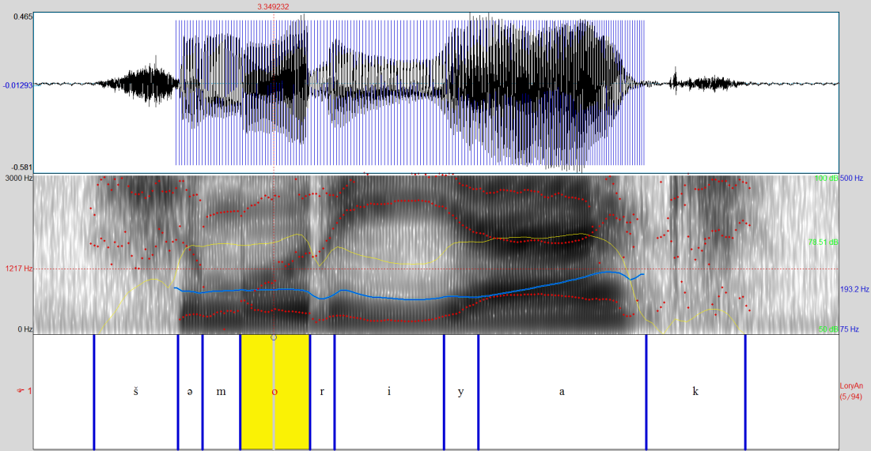
Figure 7. Formant tracks (red points) of phrase šəmōri yak number one (slide 23)
There is only one exception – nasal [ã]. But this vowel can be found in Gujarati. European books describe an Avestan diphthong [ə̄u], but neither in Iran, nor in Mumbai they pronounce [ə̄] in it. They sing it only as [ēu].
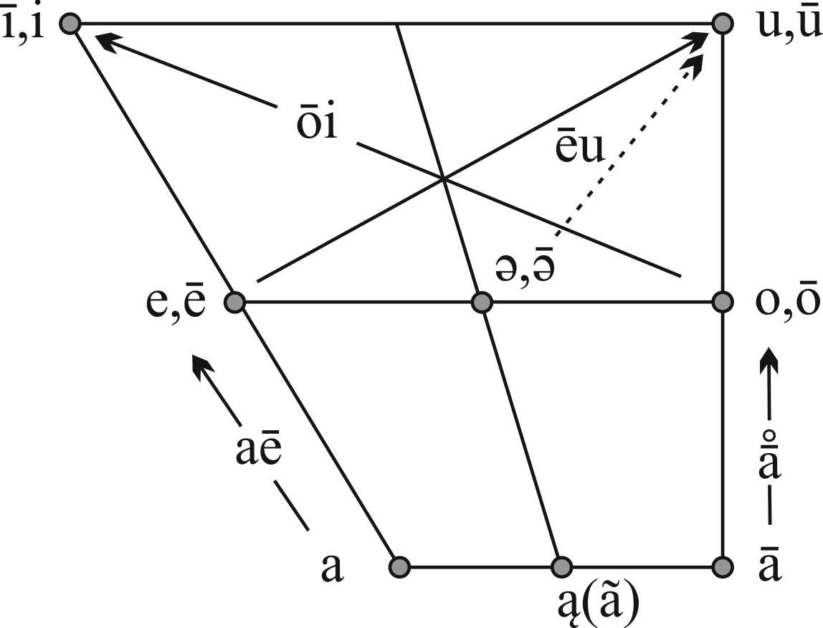
Figure 8. Avestan vowels
There are some slides about the interviews we have taken in Yazd (slides 25-31).

References
Ivanov V. B. To the Origin of Avestan Pronunciation [Book Section] // Societas Iranologica Europæa - Proceedings 2003 / ed. Panaino A. and Piras A.. - Milano : [s.n.], 2005. - Vol. I. - ISBN 88-xxxx-xxx-x.
Иванов В. Б. и Молчанова Е. К. Эволюция языка иранских зороастрийцев в условиях двуязычия [Журнал] // Вопросы филологии. - Москва : ИИЯ, ИЯ РАН, РАЛН, 2008 г.. - №2 (29). - стр. 39-46. - ISSN 1562-1391.
Иванов В. Б. и Молчанова Е. К. Язык иранских зороастрийцев (вопросы фонологии и социолингвистики) [Статья] // ICANAS XXXVII Труды. - Москва : Институт востоковедения РАН, Общество востоковедов РАН, 2007 г.. - Т. 1. - стр. 153–161. - ISBN 978-5-89282-366-1.
ایوانف و. ب. ايوانف ولاديمير. تاريخچه آواشناسي واكه‌ها در زبان اوستايي [مقاله] // فرهنگ. ويژه زبانشناسي. - تهران : پژوهشگاه علوم انساني و مطالعات فرهنگي, 1383 (2004) سال هفدهم. - جلد 3-4. - ISSN 1017-4117.
فیروزبخش فرانک بررسي ساختمان دستوري گويش بهدينان شهر يزد [كتاب]. - تهران : موسسة انتشاراتي-فرهنگي فروهر, 1375. - ص. 1-133. - ISBN 964-6320-03-1.
مزداپور كتايون واژه‌نامۀ گويش بهدينان شهر يزد. فارسي به گويش همراه با مثال [كتاب]. - تهران : پژوهشگاه علوم انساني و مطالعات فرهنگي, 1374. - جلد 1 : 2. - ISBN 964-426-272-7, ISBN 964-426-002-3.

