**22**

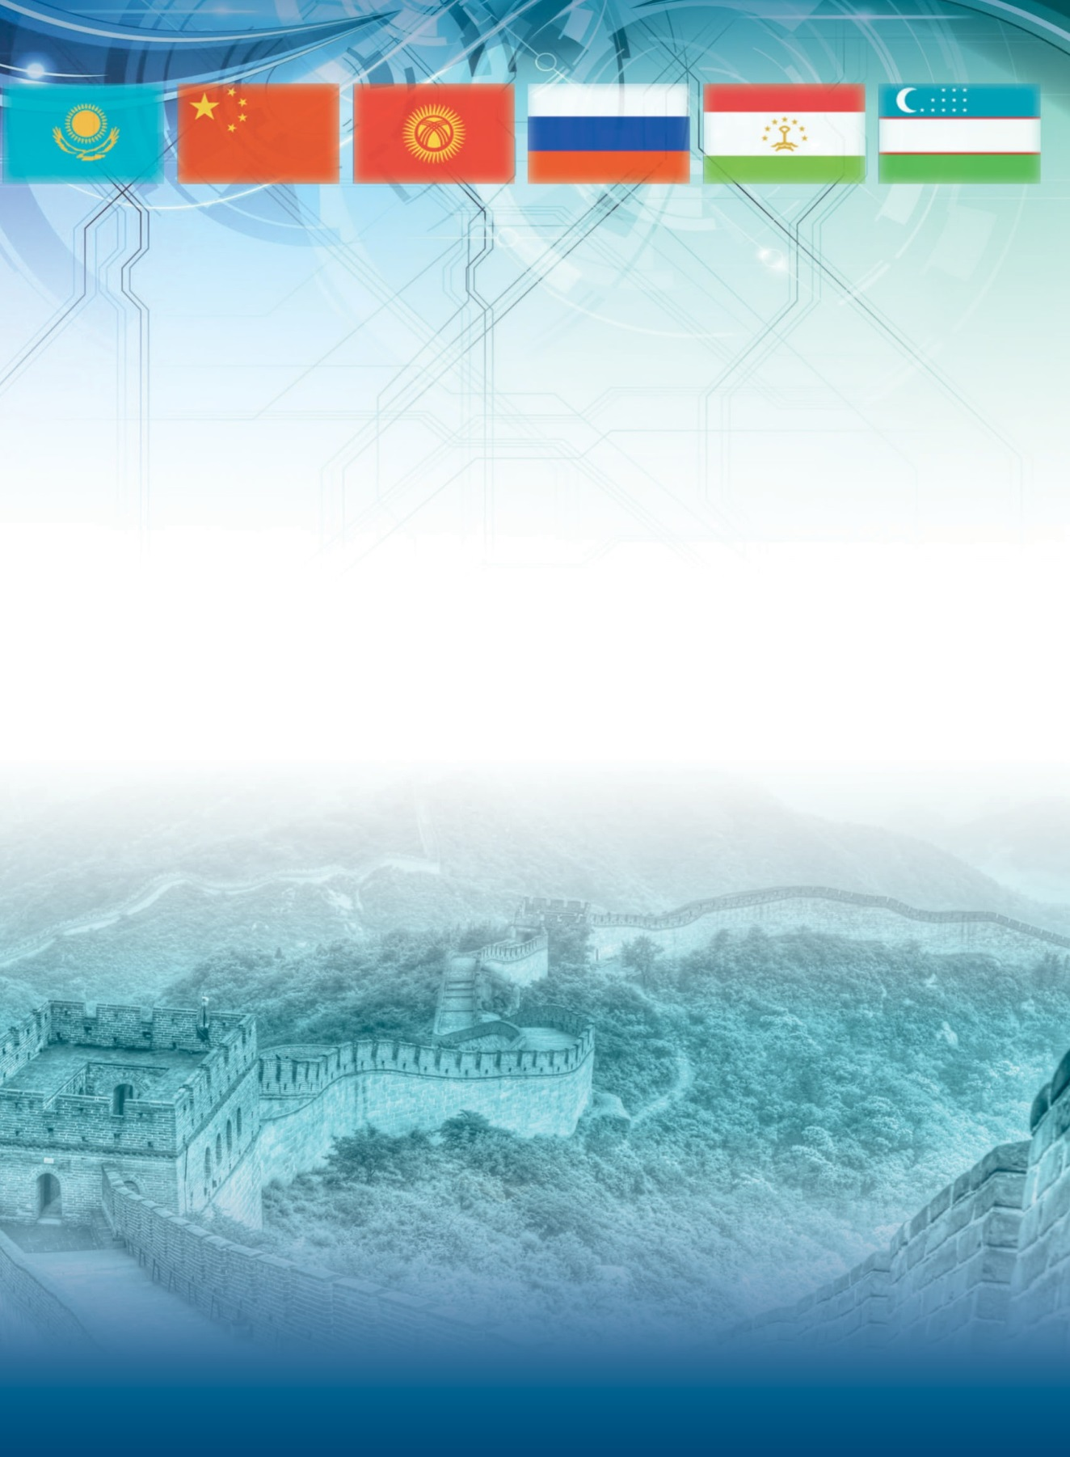

SCIENTIFIC RESEARCH OF THE SCO COUNTRIES:

SYNERGY AND INTEGRATION

上合组织国家的科学研究：协同和一体化

Proceedings of the International Conference

Date: August 10 Beijing, China 2022