Cation Protonation Degree Influence on the Formation of Anion···Anion and Other Non-Valent Interactions in Guaninium Perrhenates and Pertechnetate
Anton P. Novikov*, Konstantin E. German, Alexey V. Safonov, Mikhail S. Grigoriev
[a] A. P. Novikov, Dr. K. E. German, Dr. A. V. Safonov, Dr. M. S. Grigoriev
Frumkin Institute of Physical Chemistry and Electrochemistry, Russian Academy of Sciences
31 Bldg 4, Leninsky prosp., Moscow, 119071 (Russian Federation)
E-mail: tony.novickoff@yandex.ru

Supporting information for this article is given via a link at the end of the document.

Abstract: H₂Gua(ReO₄)₂, HGuaReO₄ and HGuaTcO₄ were first obtained and structurally characterized. Two types of anionic interactions were found in the structure with the twice protonated cation. One type of the rare double-lock interaction of perrhenate anions was found in the case of the singly protonated guanine salt. Singly charged cations are linked by hydrogen bonds into layer. π-Stacking interactions between these layers form 3-dimensional frame. Multiple and relatively abundant anion-π interactions are formed in H₂Gua(ReO₄)₂ as compared to HGuaReO₄ and HGuaTcO₄. Different types of crystal packing are formed in the compounds under research. Hirshfeld surface analysis has given evidence that the main contribution to intermolecular interactions for the cations is made by hydrogen bonds of the O···H/H···O type in all structures, O···C/C···O and O···N/N···O interactions in H₂Gua(ReO₄)₂, N···H/H···N and H···H interactions in HGuaReO₄ and HGuaTcO₄.
Introduction
Chemical interactions like anion···anion ^{[1–3]} and interactions of charged ions with π-systems (discovered recently ^{[4–10]}) are only occasionally, incompletely or fragmentally studied. Meanwhile they are attracting more and more attention of structural chemists with the improvement of modern X-ray technics, which radically raised the quality of the structures being determined. Interactions of this type can be responsible not only for structural features, often acting as an important structure-forming factor, but also determine a number of physical and chemical properties (luminescence, solubility, selectivity, etc.) ^{[7,11–16]}. Weak chemical interactions have a significant role in aromatic interactions in recognition ^{[17]}, protein folding ^{[18]}, and crystal engineering ^{[19,20]}.
Although hydrogen bonds are classified in chemistry as weak, in many systems they are very important both for the formation of structures and in the course of basic vital organic reactions, such as enzymatic ones ^{[21]}. As for hybrid compounds containing organic and inorganic components, these bonds are responsible for the dimensions and stabilization of the crystal structures and frameworks. These have been the basis for the recent advances on the crystal chemistry and coordination chemistry of perrhenates and pertechnetate aiming at enhanced separation of these anions ^{[22–26]}. Other non-valent interactions such as π-interactions (π-stacking, anion-π, anion-π-cation, anion-π-π, and cation-π interactions) are important in drug design and the operation of molecular sensors ^{[4]}.
In this work, we were attracted by the anion···anion interaction in the system XO₄– (X = Re, Tc) with guanine as the counterion. Guanine (2-amino-6-oxopurine), a nitrogenous base, is an integral part of nucleic acids ^{[27–29]}.
Therefore, data on the features of interactions between guanine and oxoanions of technetium and rhenium can be important for studying the behavior of these elements in organisms (technetium and rhenium are actively used in medicine, for example, in radiotherapy), in the environment (technetium is an abundant long-lived component of radioactive waste and pollutant capable to concentrate in several ecosystems ^{[30]}. In several new compounds studied below, some of the interactions mentioned above are very clearly manifested. We thought it expedient and quite actual to analyze them quantitatively and systematically based on the data of precise X-ray diffraction structural studies and the Hirshfeld surface analysis method.
Results and Discussion
Structural Description
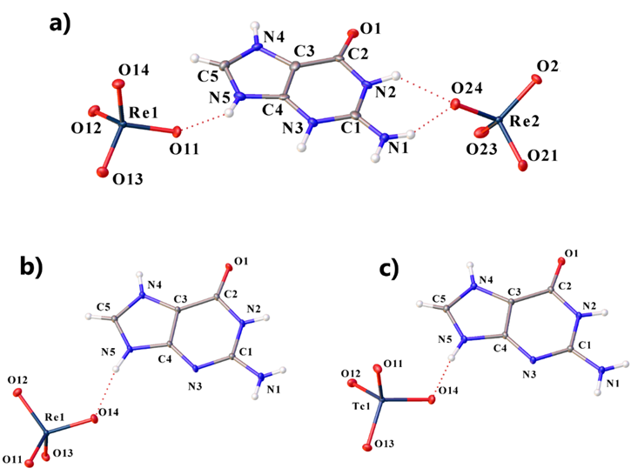
H₂Gua(ReO₄)₂ (I) crystallizes as colorless crystals in the monoclinic space group P2₁/n, HGuaReO₄ (II) and HGuaTcO₄ (III) in the triclinic P-1. In I, the guaninium cation is twice protonated, all the nitrogen atoms of the five-membered and six-membered rings are protonated, and guaninium diperrhenate is formed. In II and III, the nitrogen atom N3 remains unprotonated. The guanine molecule is protonated in the classical way ^{[31,32]}. Asymmetric fragments of compounds I-III are shown in Figure 1.
Figure 1. Molecular structure of I (a), II (b) and III (c) at 100 K, including atom labeling. Displacement ellipsoids are drawn at the 50% probability level.
NH₂ groups in all compounds are in the plane of the aromatic rings. Re–O bond lengths in perrhenate anions change from 1.713(3) to 1.735(3) Å in I, from 1.7116(14) to 1.7345(15) Å in II (Tables S1-S2). The lengths of Tc-O bonds in III change from 1.7005(10) to 1.7375(9) Å (Table S3).
The observed slight elongation of some Re/Tc-O bonds can be explained by the participation of these oxygen atoms in rather strong or multiple H-bonds. Perrhenate and pertechnetate ions are slightly distorted tetrahedra with nearly tetrahedral angles (Table S4-S6).
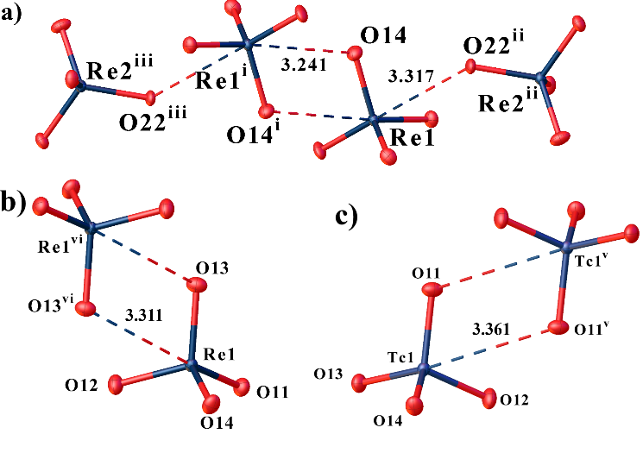
Anion···anion interactions play an important role in all structures. The anions are interconnected by the weak Re···O interaction (Figure 2). The first anion (Re1) in I is associated with two other anions (Figure 2a), and the second (Re2) with only one (Figure 2b). The geometry of this interaction is slightly different for the two anions. The first perrhenate anions form a kind of double-lock. The angle Re1–O14···Re1^{i} is 114.12º, and the angle Re2^{ii}–O22^{ii}···Re1 is 120.95º. The Re···O distance depends on the type of interaction, for the double-lock interaction it is shorter (Re1···O14^{i} distance is 3.241 Å and Re1··· O22^{ii} is 3.317 Å). In structures II and III, only the M···O interaction of the double-lock type between anions is formed (Figures 2b and 2c). The angles Re/Tc–O···Re/Tc are close to the Re1–O14···Re1^{i} angle in I and are 114.18º and 114.67º in II and III, respectively. When moving from II to III, the distance M···O lengthens slightly.
Figure 2. View showing anion···anion interactions of the first and second anions in I (a), double-lock type interaction Re···O in II (b) and Tc···O in III (c). Distances are given in angstroms.
The formation of the ReO₄···ReO₄ type dimers has been previously described for other anions of similar geometry. The work ^{[33]} describes the formation of MoO₄···MoO₄ dimers. In a recent work ^{[34]}, a new type of chemical bond named by authors “matere” bond (MaB) has been described. In this work, the authors performed calculations proving the σ-hole nature of this bond. In our work, a similar type of bonds is probably formed. The O–Re/Tc···O angles in our compounds are greater than 160º and change from 170.84 to 175.61º when going from III to I. For pertechnetate anions, this angle is smaller than for perrhenates. The Re/Tc···O distances are shorter than the sum of the van der Waals radii. But in the work ^{[34]}, no calculations were made for pertechnetate anions, and the authors limited themselves only to the analysis of structures with perrhenate and permanganate anions, having carried out only an analysis of Cambridge structural database (CSD) ^{[35]} for pertechnetate containing compounds.
In the structure of I (Figure 3a), the first anion is hydrogen bonded to three cations by N−H···:O bonds, and the second to four cations also by N−H···:O bonds. In compounds II and III the perrhenate and pertechnetate anions two O-atoms are hydrogen bonded to three cations by similar H-bonds of N−H···:O type (Figure 3b) while the rest two O-atoms are involved in anion – anion bonding (Figure 3c, discussed below). The NH and NH₂ groups in all compounds act as proton donors, while the oxygen atoms of perrhenate ions act as acceptors in H-bonds. One hydrogen bond formed by the NH₂ group in all structures is bifurcate (Table S7-S9). Structure I contains two bifurcate H-bonds. The oxygen atom of the guaninium cation in I does not participate in hydrogen bonds, but in II and III it participates in the formation of a system of hydrogen bonds.
In the anions of I, the longest Re2-O22 bond is formed due to the participation of the oxygen atom O22 in a strong N-H···:O hydrogen bond and in a single lock of the anion···anion interaction. Re1-O11, Re1-O13, Re2-O21 and Re2-O24 bonds follow in length, elongating due to the participation of oxygen atoms in one or two strong H-bonds of the N-H···:O type. Then the Re1-O14 bond goes along the length, elongating due to the participation of the oxygen atom in the double-lock interaction. In the shortest Re1-O12 and Re2-O23 bonds, the oxygen atoms do not participate in the intermolecular interactions. In II and III in anions, Re1/Tc1-O14 bond is the longest due to the participation of oxygen atoms simultaneously in two hydrogen bonds. The next longest bonds are Re1-O11 and Tc-O13, where the oxygen atoms participate in only one H-bond of the N-H···:O type. The Re1-O13 and Tc1-O11 bonds are somewhat shorter than the previous ones, but they are elongated in comparison to the shortest bonds due to participation in a double-lock interaction and a weak C-H···:O H-bond.
The crystal packing of structure I can be represented as consisting of cationic and anionic columns (Figure 3a). In I, each cation is surrounded by six anions and each anion by three cations. The columns in I are extended in the [100] direction. Additionally, anionic columns are bound by MaB. Unlike I, in II and III the guaninium cations are linked by hydrogen bonds, both among themselves and with anions. In II and III, H-bonds of the N–H···:N and N–H···:O types connect cations into chains, to which perrhenate or pertechnetate ions are attached to the side by N–H···:O bonds (Figure 3b). The chains are elongated in the [110] direction. These chains are bonded into layers by weaker hydrogen bonds of the C–H···:O type, bonds of this type are also present between the layers. “Matere” bonds additionally connect the layers to each other (Figure 3c). Only packing for II is shown, because it is the same for II and III.
Additionally, the layers in structures II and III are connected by π-stacking interaction between parallel six-membered rings of cations (centroid-centroid distance: 3.680 and 3.732 Å, shift distance 1.641 and 1.749 Å for II and III, respectively). This type of interaction is absent in the structure I. However, in all three structures there is an anion-π interaction between the oxygen atoms of the perrhenate or pertechnetate anions and the five or six-membered rings of the guaninium cations (Figure 4). This contact can be called an anion-π interaction since the distance between the center of the ring and the oxygen atom of anions is less than 5 Å, and the angle α is greater than 50° ^{[4,6,36]}.

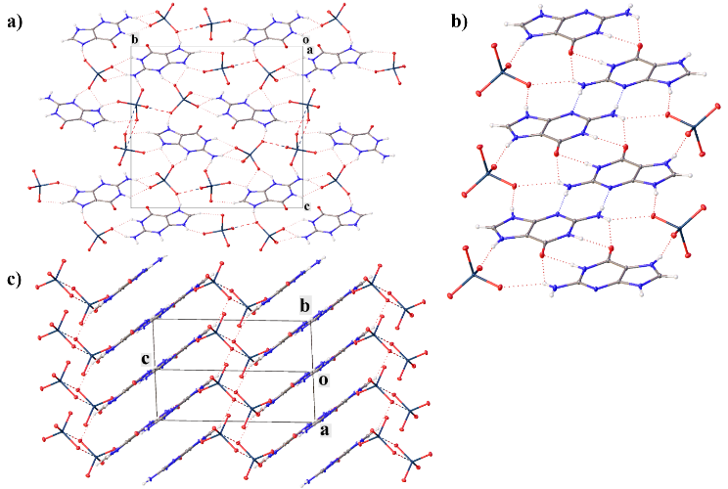
Figure 3. Crystal packing of I (a), showing cationic and anionic columns, H-bonds and MaB between them. Fragment of II showing the cationic chains (b) and crystal packing of II (c), showing the layers, viewed along the [110] direction.
Similar crystal lattice parameters (a, b, c), a similar system of hydrogen bonds and crystal packing, compounds II and III allow us to consider guaninium perrhenate and guaninium pertechnetate as isostructural. The difference between the angles α, β, γ in these structures is explained by the different setting of the reduced cell.
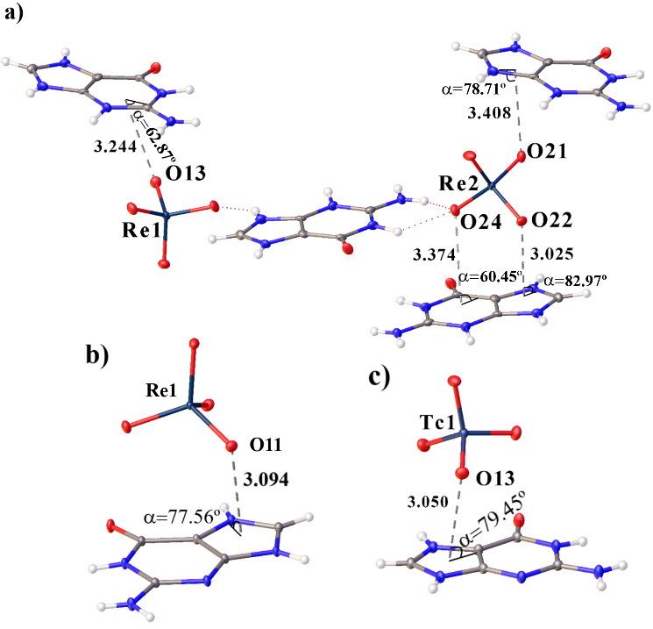
For doubly protonated guaninium in CSD, we did not find its structures with singly charged tetrahedral anions similar to the perrhenate anion. For [C₅H₇N₅O]²⁺, there are data only on hydrates of guaninium sulfate ^{[37,38]}. In these compounds, water of crystallization plays an important role in the formation of hydrogen bonds. In contrast to guaninium perrhenate, in guaninium sulfate hydrates, the oxygen atom of the guaninium cation participates in the formation of hydrogen bonds. For the singly charged cation and singly and doubly charged tetrahedral anions, data are only available for guaninium dihydrogenphosphite dihydrate ^{[31]}, guaninium dihydrogen phosphate hydrate ^{[32]}, and bis(guaninium) hydrogenphosphate hydrate ^{[39]}.
Figure 4. View showing anion-π interactions in the structures I (a), II (b) and III (c). Distances are given in angstroms.
Hirshfeld Surface Analysis
Additional analysis of supramolecular interactions in the obtained structures and their visualization were carried out using the Hirshfeld surface (HS) analysis ^{[40]} performed using the CrystalExplorer 21 program ^{[41]}.
The Hirshfeld surface covers the molecule and determines the volume of space in which the electron density of the promolecule exceeds the density of all neighboring molecules ^{[40]} . Fingerprint plots or 2D d_{norm} surface unfolding is a convenient way to summarize the intermolecular contacts present in crystals by decomposing this fingerprint plot into functions to identify specific interactions. This method can be used to analyze π-interactions (such as anion–π, anion–π–cation, anion–π–π and π-stacking) ^{[6,42]}, halogen and hydrogen bonds ^{[43,44]}, and other weak non-covalent interactions ^{[45,46]}.
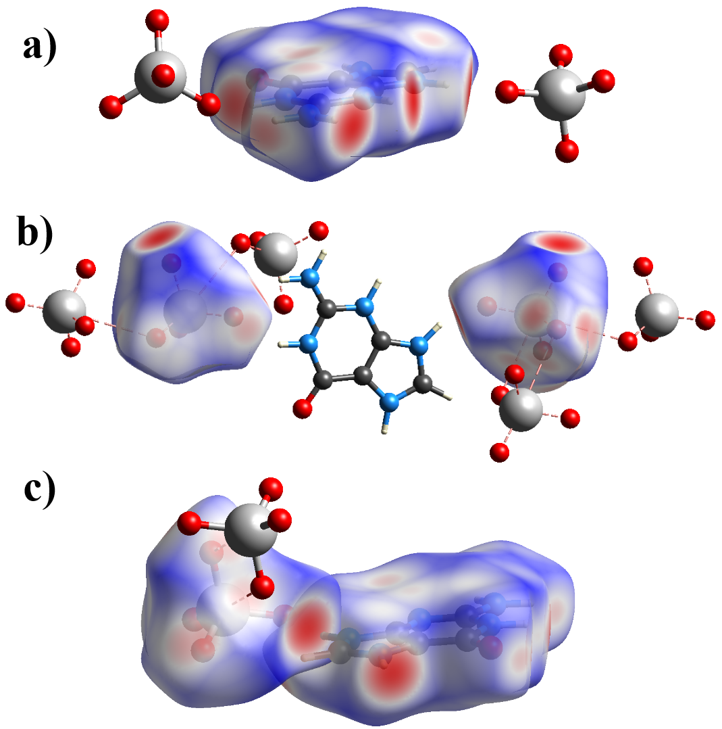
The donor-acceptor groups are visualized using a standard (high) surface resolution and d_{norm} surfaces, as illustrated in Figure 5. Red spots on the d_{norm} surface indicate short intermolecular contacts. The brightest red spots on the surface of the cations correspond to the strongest N–H···:O hydrogen bonds in both compounds and N–H···:N in II and III (Figure 5a and 5c). Weaker red spots correspond to anion-π bonds for cations in both compounds and π-stacking for cations in II and III. For compounds II and III, only the surface for compound II is shown. For the anion, red spots on the d_{norm} surface correspond to hydrogen bonds and MaB in I and II.
Figure 5. Hirshfeld surface mapper over d_{norm} for (a) cation and (b) for anions in I and for cation and anion in II (c) to visualize the short contacts.
Additionally, the absence of π-stacking interaction in I is confirmed by the absence of characteristic red and blue triangles on the Shape-index surface (Figure 6a). Such triangles can be seen in structure II (Figure 6b).

Figure 6. Hirshfeld surface mapper shape-index of cation in I (a) and II (b).
Fingerprint plots for compounds I-III are shown in Figures S1-S5 and can be used to highlight specific short interactions. The shape of the fingerprint graphs in the cation of compound I and the cations of compounds II and III is different. For example, in compound I, hydrogen bonds of the O···H/H···O type have only one sharp peak, while in compounds II and III one more elongated peak is added to them. Other types of contacts also occupy different positions on the fingerprint plots. This may be due to different degrees of cations protonation and different stoichiometry of the obtained compounds. In anions, the shape and position of points on the fingerprint plots in all three compounds differ insignificantly.
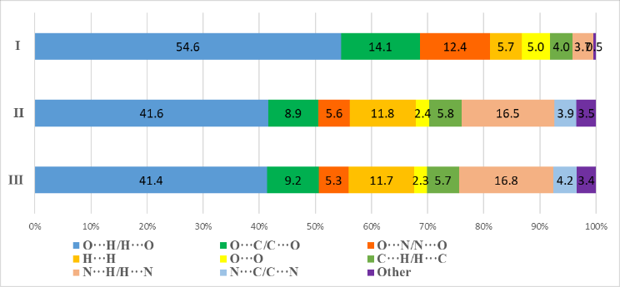
The main contribution to intermolecular interactions in cations of all compounds is made by hydrogen bonds of the type O···H/H···O and N···H/H···N (for cations). Their total contribution in all cations differ from 58.1 to 58.3% (Figure 7). However, the O···H/H···O contacts contribute more significantly to intermolecular interactions in I (54.6%) than in II (41.6%) and III (41.4%), but N···H/H···N in II (16.5%) and III (16.8%) than in I (3.7%). This may be due by different crystal packing in these compounds. In the cations of I, the interactions of the O···C/C···O and O···N/N···O types play a more significant role in the formation of crystal packing than in II and III. This may also be due to the presence in I more anion-π interactions. The van der Waals H···H interactions in II and III contribute more to the crystal packing than in I. It should be noted that interactions of the N···C/C···N type appear in the cations of II and III, which are absent in I. They are associated with the presence of π-stacking interactions in II and III.
Figure 7. Percentage contributions to the Hirshfeld surface area for the various close intermolecular contacts for cations in I-III.
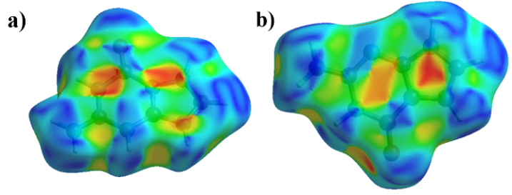
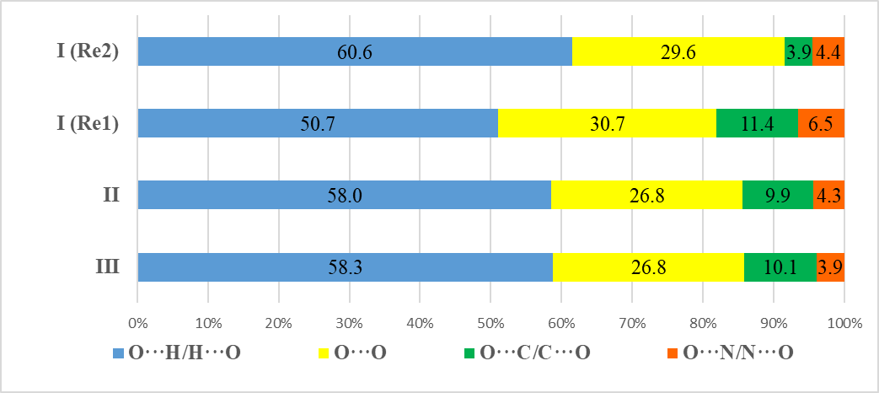
In anions, the main contribution to intermolecular interactions is made by hydrogen bonds of the O···H/H···O type. However, for the first and second anions in I, this contribution differs significantly, just as it differs for anions in II and III. Van der Waals O···O interactions also play a significant role in the anions of all compounds. The presence of O···C/C···O and O···N/N···O contacts, as well as for cations, is explained by the anion-π interactions between cations and anions in all compounds. Replacing a rhenium atom with a technetium atom does not introduce significant changes in the Hirschfeld surfaces and fingerprint plots. The proportion of O···M/M···O interactions in all anions is about 1% and is not shown in Figure 8.
Figure 8. Percentage contributions to the Hirshfeld surface area for the various close intermolecular contacts for anions in I-III.
Conclusion
HGua⁺ and H₂Gua²⁺ perrhenates, and HGua⁺ pertechnetate have been synthesized for the first time and structurally characterized. Compounds HGuaReO₄ and HGuaTcO₄ proved to be isostructural. The stoichiometry of compounds changes the types of interion interactions and their number. The rise in the cation/anion ratio leads to an increase in intercation interactions and a decrease in cation···anion and anion···anion interactions when going from I to II and III. In I and II-III, different systems of hydrogen bonds and crystal packing are formed. Doubly charged cations are not connected to each other by hydrogen bonds. The singly charged ones are connected into chains by hydrogen bonds of the N-H···:N and C-H···:N types. There are more anion-π interactions in the compound with the doubly charged cation (I) than with the singly charged one (II, III). Singly charged cations are additionally linked to each other by π-stacking interaction, which is absent in the structure with the doubly charged cation. In the structure with one anion, anionic dimers are formed, bound by a double-lock interaction. In the structure with two anions, these dimers are additionally linked by the Re···O interaction and form anionic chains. Thus, the anion-anion interactions (when present) prove to be an essential part of weak interactions in the structures under consideration and could be a feature of changes in several purine structures. An analysis of the Hirshfeld surface showed that the main contribution to intermolecular interactions is made by hydrogen bonds O···H/H···O and N···H/H···N (for cations).
Experimental Section
Caution: Technetium-99 is a weak beta emitter (E_{max} = 292 keV, specific activity 635 Bq/μg). All manipulations were performed in a laboratory designed for chemical synthesis with radionuclides using efficient HEPA-filtered fume hoods, Schlenk and glove box techniques, and following locally approved radioisotope handling and monitoring procedures.
To obtain single crystals of guaninium perrhenates and pertechnetates, we used chemically pure reagents sodium perrhenate (Sigma Aldrich), guanine (Sigma Aldrich) and sodium pertechnetate produced by VO Izotop.
Synthesis of complexes guaninium diperrhenate (H₂Gua(ReO₄)₂) (I) and perrhenate (HGuaReO₄) (II).
In a 10 mL two-neck flask equipped with a thermometer and a reflux condenser, 20 mg of guanine was dissolved in 2.5 mL of 1 m HCl for I and 0.5 m HCl for II at room temperature. After dissolving all the guanine, 2.5 mL of an aqueous solution of sodium perrhenate was added. Sodium perrhenate solution was prepared by dissolving of 30 mg (for complex I) and 10 mg (for complex II) of its salt in 2.5 mL of 1 m HCl for I and 0.5 m HCl for II at room temperature. The mixture was stirred for 5 min at room temperature, then the temperature was raised to 70ºC and held for 15 min. The resulting solution was cooled to room temperature and left for 10 days for crystals growth. The resulting crystals were washed with two 5 mL portions of cold methanol and dried in an oil pump vacuum at room temperature.
Elem. anal. calcd for C₅H₇N₅O₉Re₂(I): C, 9.19; H, 1.08; N, 10.72. Found: C, 9.32; H, 1.10; N, 10.53. Calcd for C₅H₆N₅O₅Re(II): C, 14.93; H, 1.50; N, 17.41. Found: C, 15.15; H, 1.52; N, 17.14.
Synthesis of Complexes guaninium pertechnetate (HGuaTcO₄) (III).
In a 10 mL two-necked flask equipped with a thermometer and a reflux condenser, 20 mg of guanine was dissolved in 2.5 mL of 0.5 m HCl. After dissolving all the guanine, 2.5 ml of sodium pertechnetate solution was added. The sodium pertechnetate solution was prepared by dissolving of 15 mg its salt in 2.5 mL of 0.5 m HCl at room temperature. The mixture was stirred for 5 min at room temperature, then the temperature was raised to 70ºC and held for 15 min. The resulting solution was cooled to room temperature and left for 10 days for crystals growth. The resulting crystals were washed with two 5 mL portions of cold methanol and dried in an oil pump vacuum at room temperature.
When using an acid concentration of 0.5 m or lower, a one-protonated cation was formed. Using 1 M HCl resulted in two-protonated cation formation. The crystals of the obtained compounds were up to 0.5–1 mm in size, transparent, colorless, and crystallized in the form of needles. They were weakly hygroscopic and readily soluble in water, in contrast to the original nitrogenous base.
The precipitate I so obtained was characterized by X-ray powder diffraction analysis; the diffraction pattern (Figure S6) was in a good agreement with the theoretical one and does not contain peaks corresponding to the starting substances. For compound II, the amount of the precipitate was insufficient for X-ray powder analysis. Some good crystals were selected for single-crystal X-ray diffraction studies.
Elem. anal. calcd for C₅H₆N₅O₅Tc(III): C, 19.06; H, 1.92; N, 22.23. Found: C, 19.25; H, 1.94; N, 22.45.
2.3. Single-Crystal XRD Analysis
The crystal structure of all synthesized substances was determined by X-ray structural analysis using an automatic four-circle area-detector diffractometer Bruker KAPPA APEX II with MoKα radiation at 100 K. The unit cell parameters were refined over the entire dataset together with data reduction by using SAINT-Plus software ^{[47]}. Absorption corrections were introduced using the SADABS program ^{[48]}. The structures were solved a direct method with the SHELXS97 ^{[49]} and refined by SHELXL-2018/3 ^{[50]}. The H atoms in NH, NH₂, CH groups were located from different Fourier maps and refined with fixed isotropic displacement parameters [U_{iso}(H) = 1.2 U_{eq}(C, N)]. Tables and pictures for structures were generated by Olex2 ^{[51]}.
Crystal data, data collection, and structure refinement details are summarized in Table 1. All other crystallographic parameters of structures I - III are indicated in Tables S1−S9.
Deposition Numbers https://www.ccdc.cam.ac.uk/services/structures?id=doi:10.1002/slct.202202814"> 2173922 (for I), 2173923 (for II), and 2173924 (for III) contain the supplementary crystallographic data for this paper. These data are provided free of charge by the joint Cambridge Crystallographic Data Centre and Fachinformationszentrum Karlsruhe http://www.ccdc.cam.ac.uk/structures ">Access Structures service.
Table 1. Crystal data and structure refinement for structures I-III.
 | I | II | III
Empirical formula | C₅H₇N₅O₉Re₂ | C₅H₆N₅O₅Re | C₅H₆N₅O₅Tc
Formula weight/ g/mol | 653.56 | 402.35 | 314.15
Temperature/K | 100(2)
Crystal system | monoclinic | triclinic | triclinic
Space group | P2₁/n | P-1 | P-1
a/Å | 5.2014(2) | 5.5036(2) | 5.4073(2)
b/Å | 15.7463(6) | 7.2041(2) | 7.2230(3)
c/Å | 14.9004(5) | 12.4608(3) | 12.5344(5)
α/° | 90 | 73.315(1) | 106.129(2)
β/° | 92.908(2) | 79.613(1) | 91.945(2)
γ/° | 90 | 75.838(1) | 104.688(2)
Volume/Å³ | 1218.81(8) | 455.64(2) | 452.04(3)
Z | 4 | 2 | 2
ρ_{calc}g/cm³ | 3.562 | 2.933 | 2.308
μ/mm⁻¹ | 19.905 | 13.354 | 1.611
F(000) | 1176.0 | 372.0 | 308.0
Crystal size/mm³ | 0.18 × 0.12 × 0.1 | 0.16 × 0.13 × 0.09 | 0.34 × 0.18 × 0.14
Radiation | MoKα (λ = 0.71073)
2Θ range for data collection/° | 8.178 to 54.996 | 8.46 to 69.996 | 8.192 to 69.998
Index ranges | -6 ≤ h ≤ 6, -20 ≤ k ≤ 20, -19 ≤ l ≤ 19 | -8 ≤ h ≤ 8, -11 ≤ k ≤ 11, -20 ≤ l ≤ 20 | -8 ≤ h ≤ 8, -11 ≤ k ≤ 11, -17 ≤ l ≤ 20
Reflections collected | 11540 | 12118 | 12168
Independent reflections | 2785 [R_{int} = 0.0375, R_{sigma} = 0.0312] | 4011 [R_{int} = 0.0230, R_{sigma} = 0.0246] | 3978 [R_{int} = 0.0209, R_{sigma} = 0.0235]
Data/restraints/parameters | 2785/0/205 | 4011/0/169 | 3978/0/163
Goodness-of-fit on F² | 1.047 | 1.090 | 1.054
Final R indexes [I>=2σ (I)] | R₁ = 0.0198, wR₂ = 0.0402 | R₁ = 0.0152, wR₂ = 0.0324 | R₁ = 0.0190, wR₂ = 0.0427
Final R indexes [all data] | R₁ = 0.0244, wR₂ = 0.0414 | R₁ = 0.0164, wR₂ = 0.0327 | R₁ = 0.0209, wR₂ = 0.0434
Largest diff. peak/hole / e Å⁻³ | 0.93/-1.04 | 1.27/-1.34 | 0.68/-0.61

2.4. Powder XRD Analysis
X-ray phase analysis was performed on a PANalytical AERIS diffractometer with a Cu (λ = 1.5418 Å) anode (40 kV). The analysis was performed over a 2Ɵ angle range from 10 to 60˚. The diffraction patterns were processed using the HighScorePlus program ^{[52]}.
Acknowledgements
X-ray diffraction experiments were performed at the Center for Shared Use of Physical Methods of Investigation at the Frumkin Institute of Physical Chemistry and Electrochemistry, RAS. The study was supported by the Ministry of Science and Higher Education of the Russian Federation (program no. 122011300061-3).
Keywords: anion···anion interactions • non-valent interactions • perrhenate • pertechnetate • X-ray diffraction •
References
[1] Y. V. Nelyubina, M. Y. Antipin, K. A. Lyssenko, J. Phys. Chem. A 2007, 111, 1091–1095.
[2] Y. V. Nelyubina, K. A. Lyssenko, R. G. Kostyanovsky, D. A. Bakulin, M. Y. Antipin, Mendeleev Commun. 2008, 18, 29–31.
[3] Y. V. Nelyubina, K. A. Lyssenko, V. Y. Kotov, M. Y. Antipin, J. Phys. Chem. A 2008, 112, 8790–8796.
[4] X. Lucas, A. Bauzá, A. Frontera, D. Quiñonero, Chem. Sci. 2016, 7, 1038–1050.
[5] A. P. Novikov, M. A. Volkov, A. V. Safonov, M. S. Grigoriev, E. V. Abkhalimov, Crystals 2021, 11, 1417.
[6] A. P. Novikov, M. A. Volkov, A. V. Safonov, M. S. Grigoriev, Crystals 2022, 12, 271.
[7] B. L. Schottel, H. T. Chifotides, K. R. Dunbar, Chem. Soc. Rev. 2007, 37, 68–83.
[8] P. Gamez, T. J. Mooibroek, S. J. Teat, J. A. N. Reedijk, Acc. Chem. Res. 2007, 40, 435–444.
[9] S. Tsuzuki, K. Honda, T. Uchimaru, M. Mikami, K. Tanabe, J. Am. Chem. Soc. 2000, 122, 11450–11458.
[10] J. C. Ma, D. A. Dougherty, Chem. Rev. 1997, 97, 1303–1324.
[11] S. Scheiner, Noncovalent Forces, Springer International Publishing, 2015.
[12] M. Nishio, Tetrahedron 2005, 61, 6923–6950.
[13] A. Frontera, P. Gamez, M. Mascal, T. J. Mooibroek, J. Reedijk, Angew. Chemie Int. Ed. 2011, 50, 9564–9583.
[14] X. Liu, K. E. O’Harra, J. E. Bara, C. H. Turner, Phys. Chem. Chem. Phys. 2020, 22, 20618–20633.
[15] G. Li, F. Song, D. Wu, J. Lan, X. Liu, J. Wu, S. Yang, D. Xiao, J. You, Adv. Funct. Mater. 2014, 24, 747–753.
[16] V. V. Sivchik, A. I. Solomatina, Y. T. Chen, A. J. Karttunen, S. P. Tunik, P. T. Chou, I. O. Koshevoy, Angew. Chemie Int. Ed. 2015, 54, 14057–14060.
[17] N. S. Scrutton, A. R. C. Raine, Biochem. J. 1996, 319, 1–8.
[18] T. Steiner, G. Koellner, J. Mol. Biol. 2001, 305, 535–557.
[19] M. Giese, M. Albrecht, K. Rissanen, Chem. Rev. 2015, 115, 8867–8895.
[20] K. Müller-Dethlefs, P. Hobza, Chem. Rev. 2000, 100, 143–167.
[21] W. H. Elliott, D. C. Elliott, Biochemistry and Molecular Biology, Oxford University Press, 2009.
[22] R. Xie, N. Shen, X. Chen, J. Li, Y. Wang, C. Zhang, C. Xiao, Z. Chai, S. Wang, Inorg. Chem. 2021, 60, 6463–6471.
[23] L. Zhu, D. Sheng, C. Xu, X. Dai, M. A. Silver, J. Li, P. Li, Y. Wang, Y. Wang, L. Chen, C. Xiao, J. Chen, R. Zhou, C. Zhang, O. K. Farha, Z. Chai, T. E. Albrecht-Schmitt, S. Wang, J. Am. Chem. Soc. 2017, 139, 14873–14876.
[24] D. Sheng, L. Zhu, C. Xu, C. Xiao, Y. Wang, Y. Wang, L. Chen, J. Diwu, J. Chen, Z. Chai, T. E. Albrecht-Schmitt, S. Wang, Environ. Sci. Technol. 2017, 51, 3471–3479.
[25] L. Zhu, C. Xiao, X. Dai, J. Li, D. Gui, D. Sheng, L. Chen, R. Zhou, Z. Chai, T. E. Albrecht-Schmitt, W. Shuao, Environ. Sci. Technol. Lett. 2017, 4, 316–322.
[26] D. Sheng, L. Zhu, X. Dai, C. Xu, P. Li, C. I. Pearce, C. Xiao, J. Chen, R. Zhou, O. K. Farha, Z. Chai, S. Wang, Angew. Chemie Int. Ed. 2019, 58, 4968–4972.
[27] K. Biradha, S. Samai, A. C. Maity, S. Goswami, Cryst. Growth Des. 2010, 10, 937–942.
[28] K. Barral, S. Priet, J. Sire, J. Neyts, J. Balzarini, B. Canard, K. Alvarez, J. Med. Chem. 2006, 49, 7799–7806.
[29] X. Wang, C. Qian, X. Wang, T. Li, Z. Guo, Biosens. Bioelectron. 2020, 150, 111841.
[30] K. E. German, A. V. Safonov, D. A. Zelenina, A. V. Sitanskaya, K. A. Boldyrev, E. V. Belova, J. Environ. Radioact. 2021, 237, 106716.
[31] L. Bendheif, K. Bouchouit, N. Benali-Cherif, Acta Crystallogr. Sect. E Struct. Reports Online 2003, 59, 1407–1409.
[32] E. E. Bendeif, S. Dahaoui, N. Benali-Cherif, C. Lecomte, Acta Crystallogr. Sect. B Struct. Sci. 2007, 63, 448–458.
[33] M. S. Grigor’ev, N. А. Baturin, A. M. Fedoseev, N. A. Budantseva, Koord. Khimiya 1994, 20, 552–556.
[34] A. Daolio, A. Pizzi, G. Terraneo, A. Frontera, G. Resnati, ChemPhysChem 2021, 22, 2281–2285.
[35] C. R. Groom, I. J. Bruno, M. P. Lightfoot, S. C. Ward, Acta Crystallogr. Sect. B Struct. Sci. Cryst. Eng. Mater. 2016, 72, 171–179.
[36] M. Savastano, C. García, M. D. López de la Torre, F. Pichierri, C. Bazzicalupi, A. Bianchi, M. Melguizo, Inorganica Chim. Acta 2018, 470, 133–138.
[37] A. Cherouana, N. Benali-Cherif, L. Bendjeddou, Acta Crystallogr. Sect. E Struct. Reports Online 2003, 59, 180–182.
[38] K. Hoxha, T. J. Prior, Solid State Sci. 2013, 23, 102–108.
[39] J. N. Low, P. Tollin, D. W. Young, S. N. Scrimgeour, Acta Crystallogr. Sect. C Cryst. Struct. Commun. 1986, 42, 1045–1047.
[40] M. A. Spackman, D. Jayatilaka, CrystEngComm 2009, 11, 19–32.
[41] P. R. Spackman, M. J. Turner, J. J. McKinnon, S. K. Wolff, D. J. Grimwood, D. Jayatilaka, M. A. Spackman, J. Appl. Crystallogr. 2021, 54, 1006–1011.
[42] J. J. Piña, D. M. Gil, H. Pérez, Comput. Theor. Chem. 2021, 1197, 113133.
[43] P. H. Marek, M. Urban, I. D. Madura, Acta Crystallogr. Sect. C Struct. Chem. 2018, 74, 1509–1517.
[44] A. P. Novikov, A. A. Bezdomnikov, M. S. Grigoriev, K. E. German, Acta Crystallogr. Sect. E Crystallogr. Commun. 2022, 78, 80–83.
[45] V. Psycharis, D. Dermitzaki, C. P. Raptopoulou, Cryst. 2021, Vol. 11, Page 1246 2021, 11, 1246.
[46] S. L. Tan, M. M. Jotani, E. R. T. Tiekink, Acta Crystallogr. Sect. E Crystallogr. Commun. 2019, 75, 308–318.
[47] U. Bruker AXS Inc.: Madison, WI, 2020.
[48] L. Krause, R. Herbst-Irmer, G. M. Sheldrick, D. Stalke, J. Appl. Crystallogr. 2015, 48, 3–10.
[49] G. M. Sheldrick, Acta Crystallogr. Sect. A Found. Crystallogr. 2008, 64, 112–122.
[50] G. M. Sheldrick, Acta Crystallogr. Sect. C Struct. Chem. 2015, 71, 3–8.
[51] O. V. Dolomanov, L. J. Bourhis, R. J. Gildea, J. A. K. Howard, H. Puschmann, J. Appl. Crystallogr. 2009, 42, 339–341.
[52] T. Degen, M. Sadki, E. Bron, U. König, G. Nénert, in Powder Diffr., Cambridge University Press, 2014, pp. S13–S18.

Entry for the Table of Contents

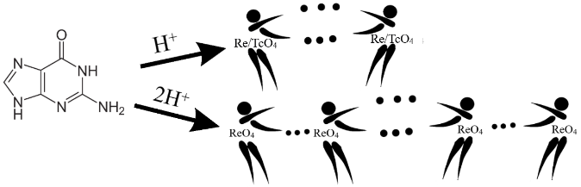
In this work, guaninium perrhenates and pertechnetate were obtained for the first time and structurally characterized. The influence of the decrease in cation protonation on non-valent interactions in crystals, including anion···anion interactions between perrhenate or pertechnetate anions, π-stacking between cations, and anion-π interactions, is discussed. Additional quantitative analysis of non-valent interactions was carried out using Hirshfeld surface analysis.

